# **Experiment 15:Using DynamoDB, performing CRUD operations**

# **STEP 1: Create DynamoDB Table (Only Once)**

### **Go to AWS Console**

1. Open [DynamoDB Console](https://console.aws.amazon.com/dynamodb)
2. Click **Tables > Create Table**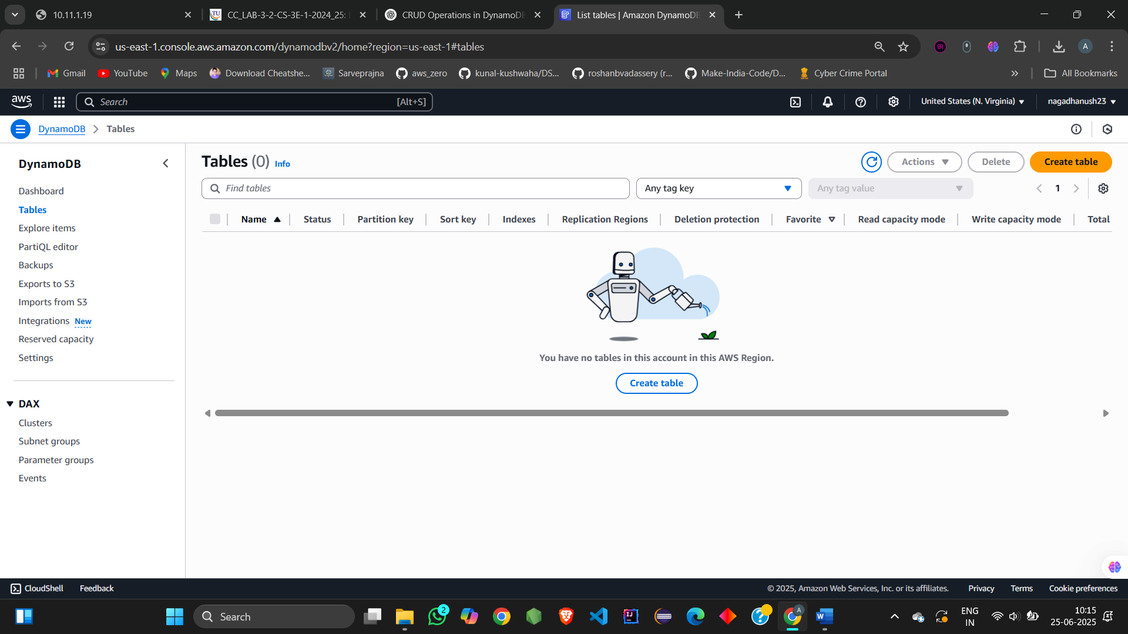

### **🧾 Fill Table Details:**

|  |  |
| --- | --- |
| **Setting** | **Value** |
| Table name | Users |
| Partition key | UserID (String) |
| Sort key | *(leave blank)* |
| Other settings | Default |

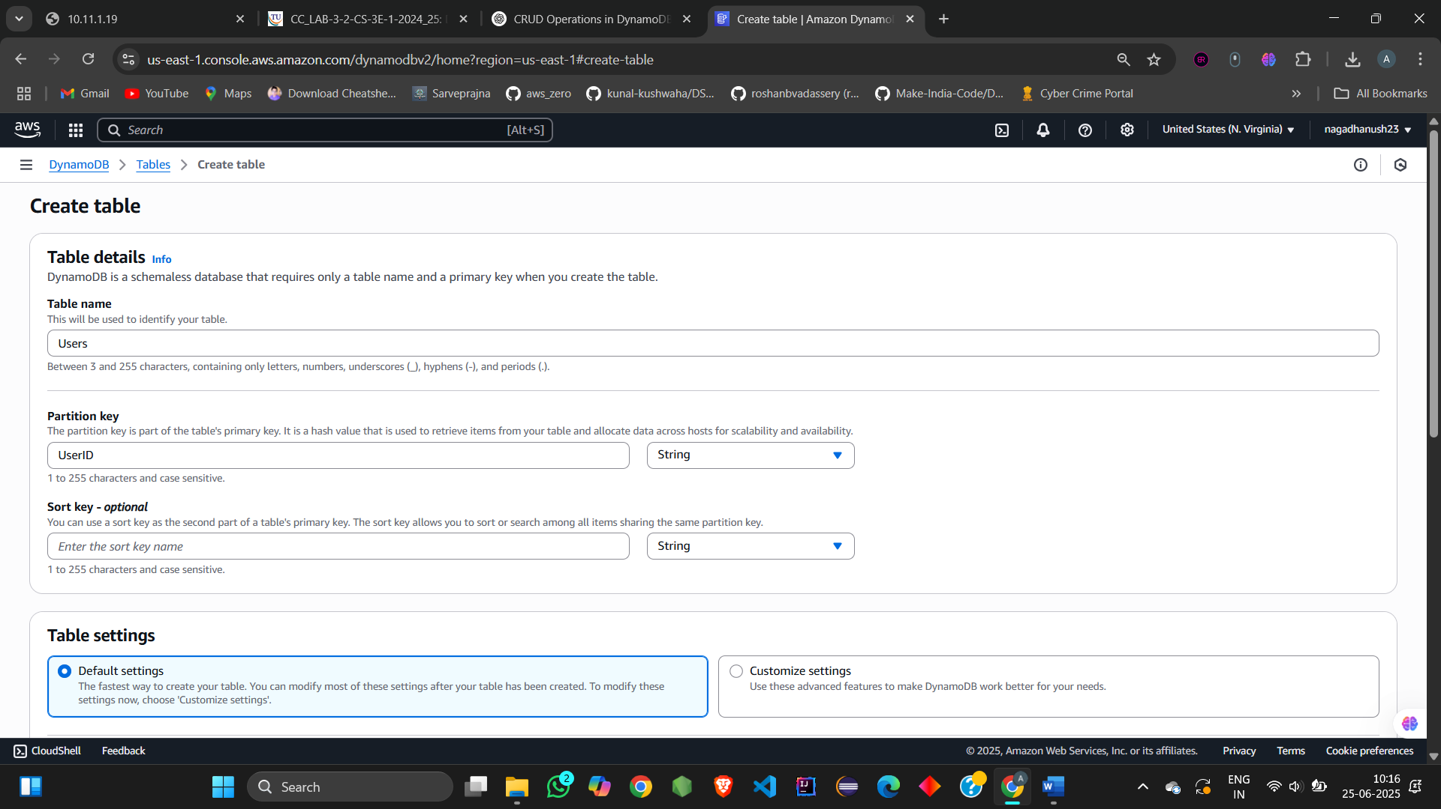

1. Click **Create Table**

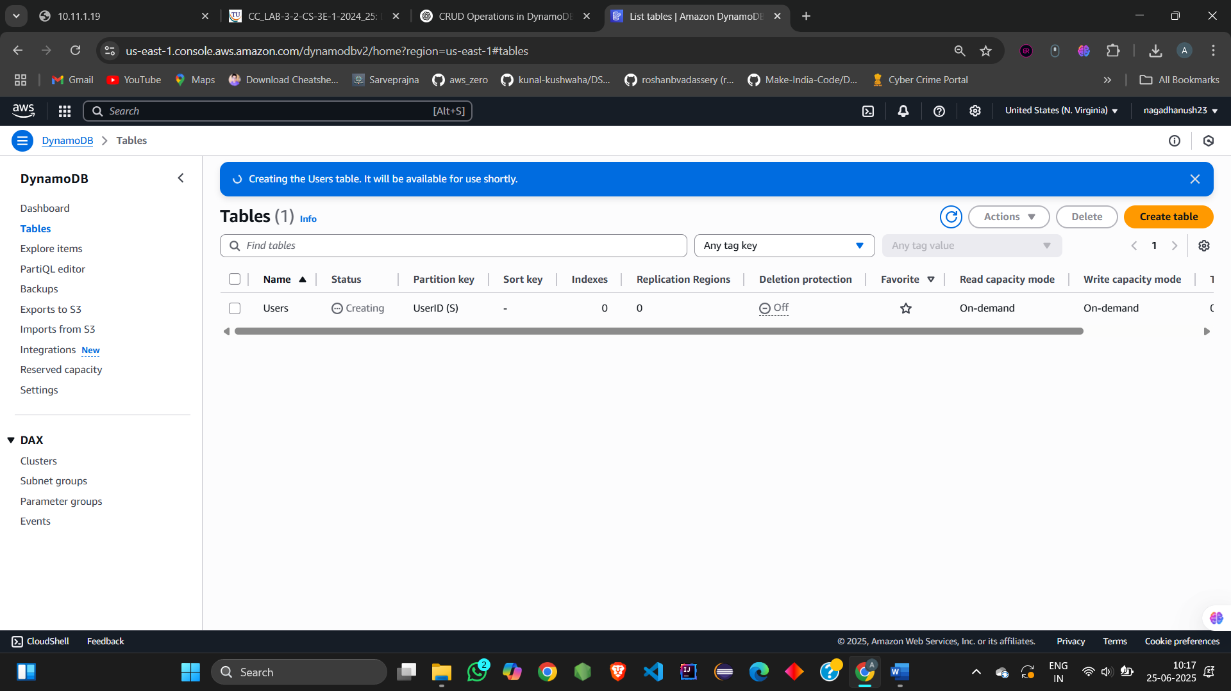

1. Wait for status = **Active**

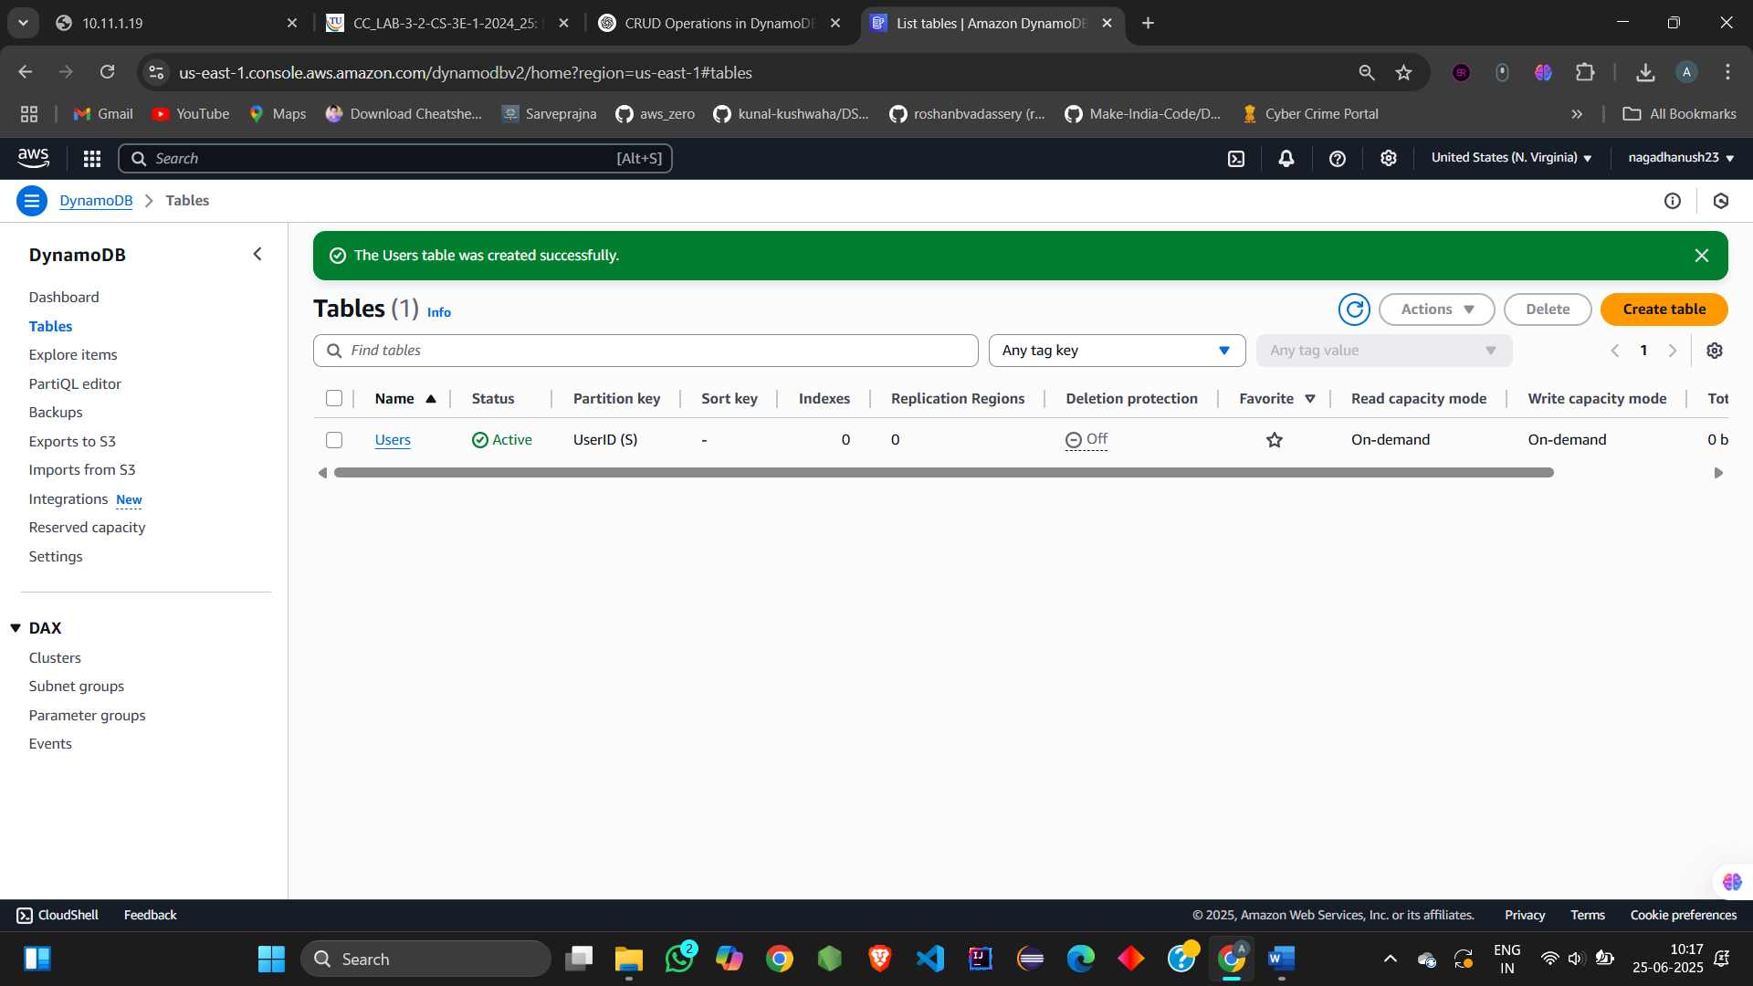

**STEP 2: CRUD Using Form View**

**Create Items using Form**

1. Go to **Tables > Users > Explore Table Items**

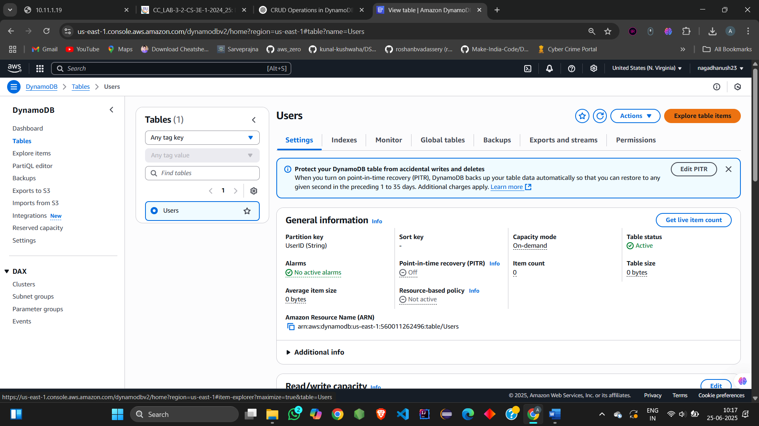

1. Click **Create item**

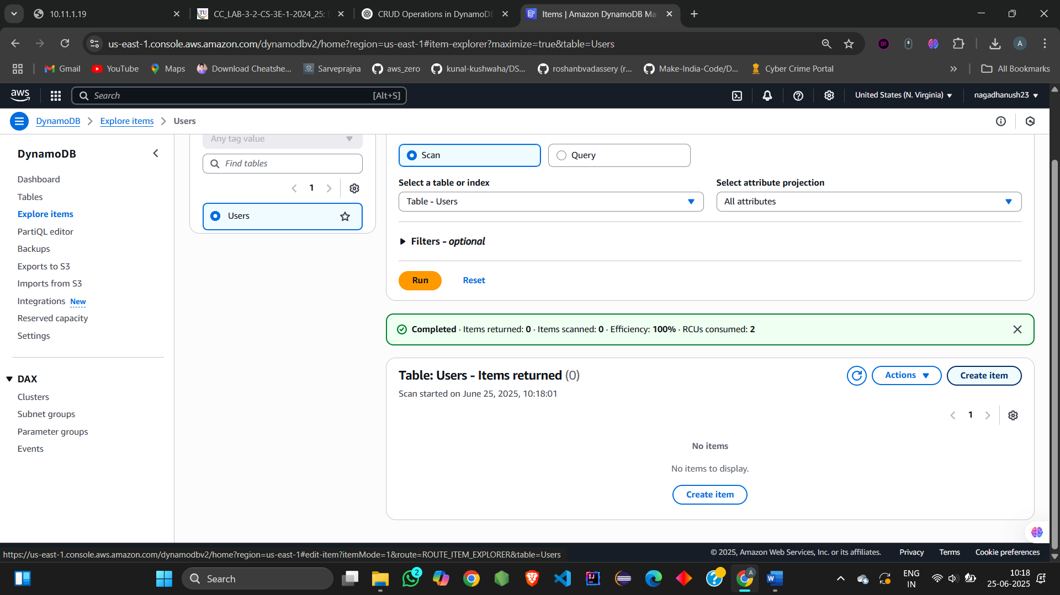

1. Use **Form View**:

UserID: U001

Name: Ashrith

Age: 21

Email: ashrithbunny13@example.com

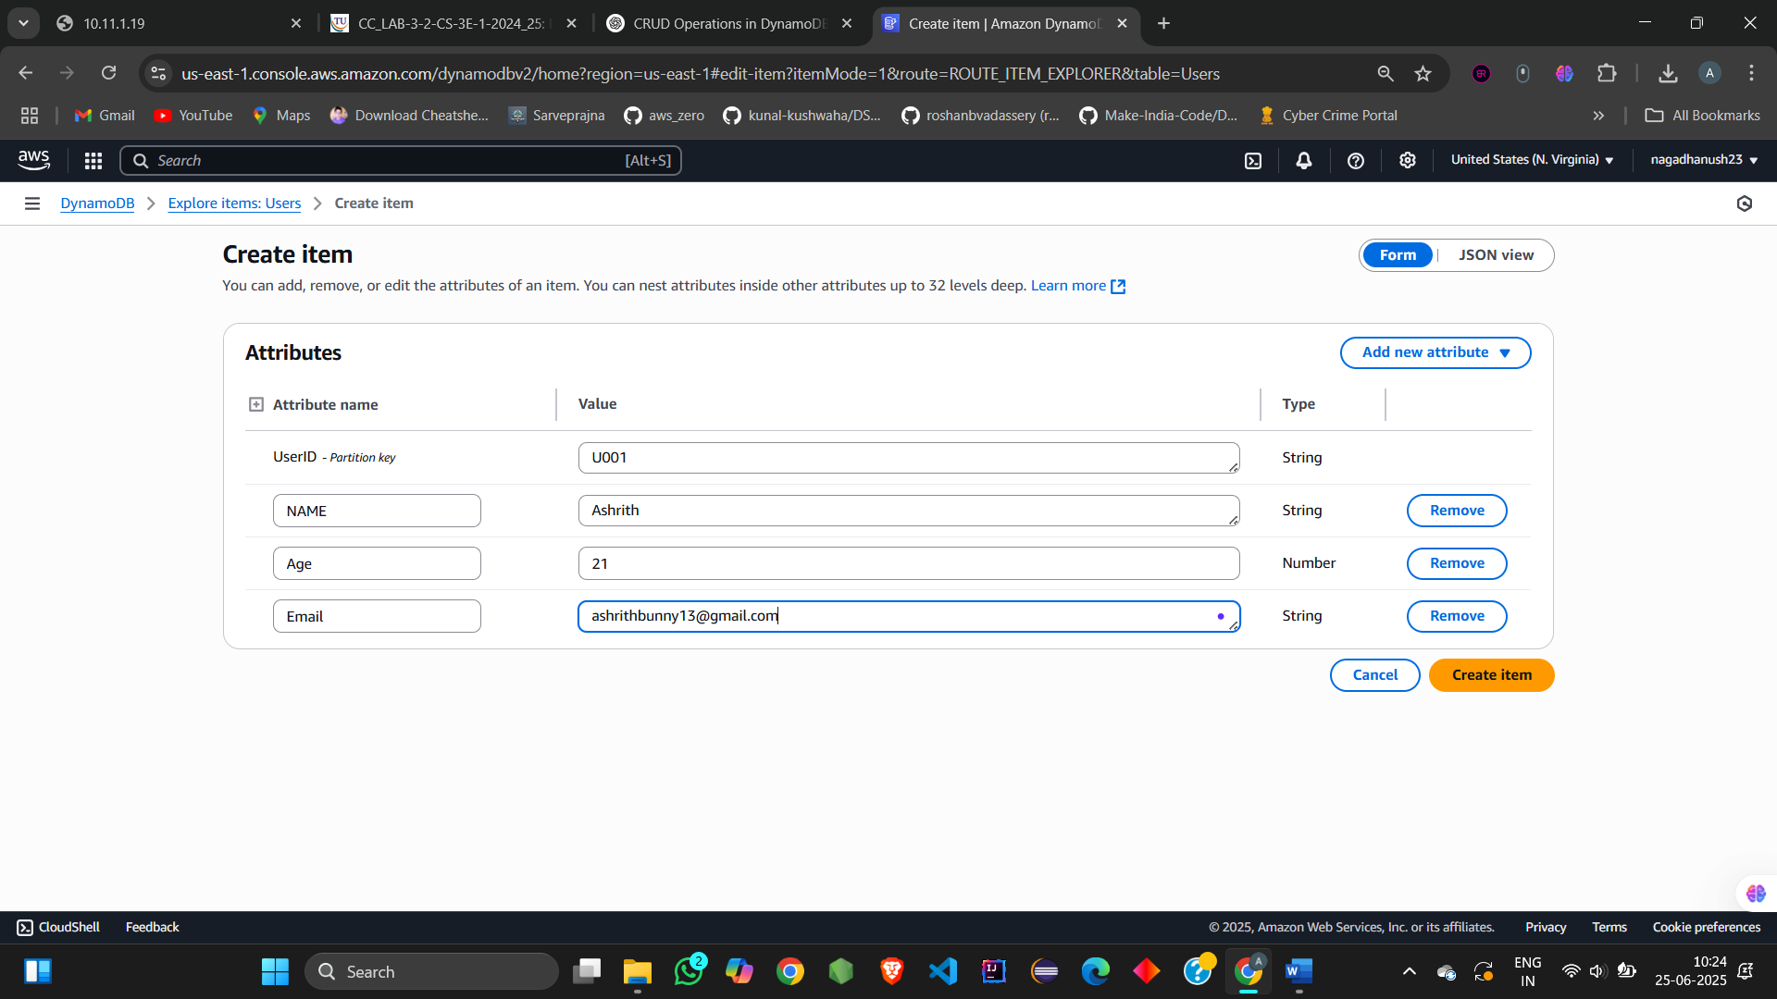

1. Click **Create item**

Repeat the process for:

UserID: U002 | Name: kowshik | Age: 25 | Email: ash@example.com

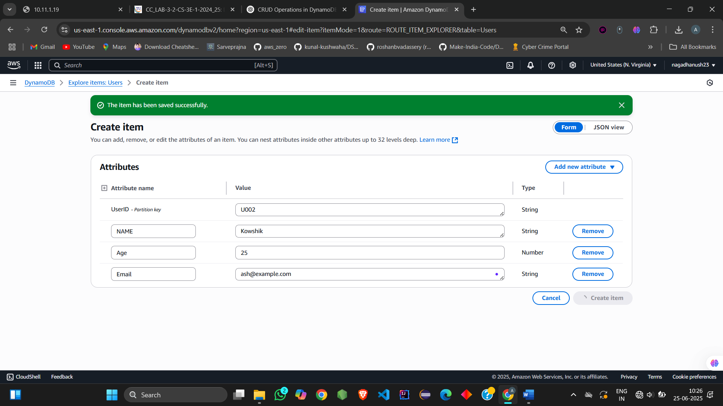

UserID: U003 | Name: ciril | Age: 25 | Email: 123@example.com

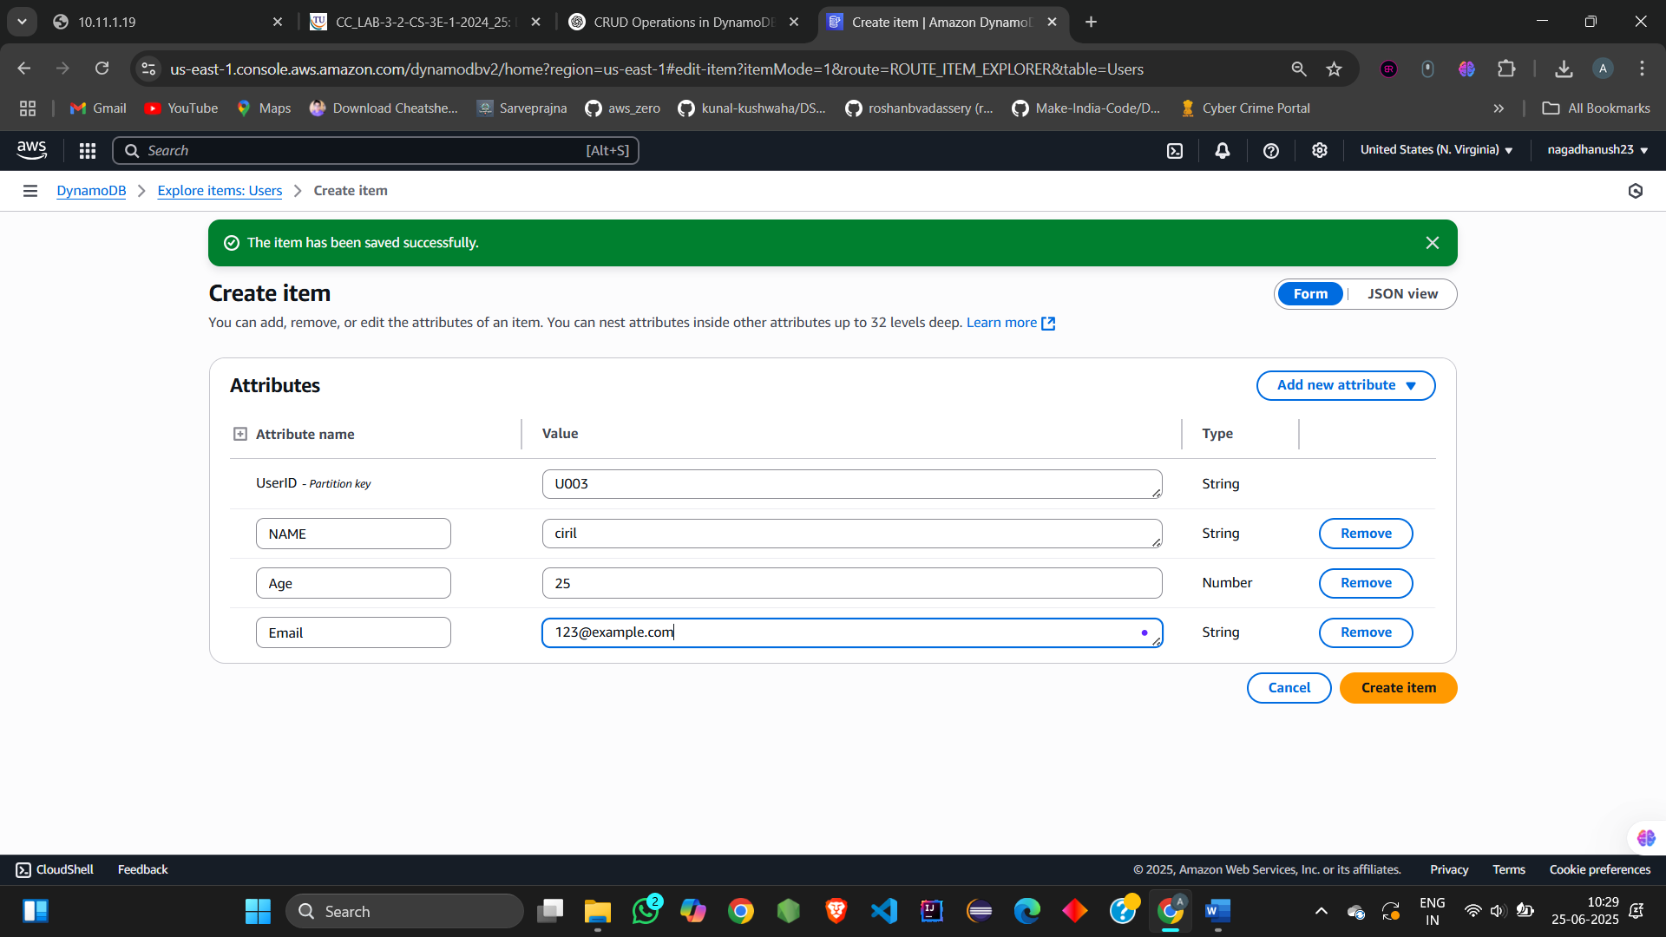

**Read (Form)**

* Go to **Explore Table Items**
* See all existing items in a table-like view

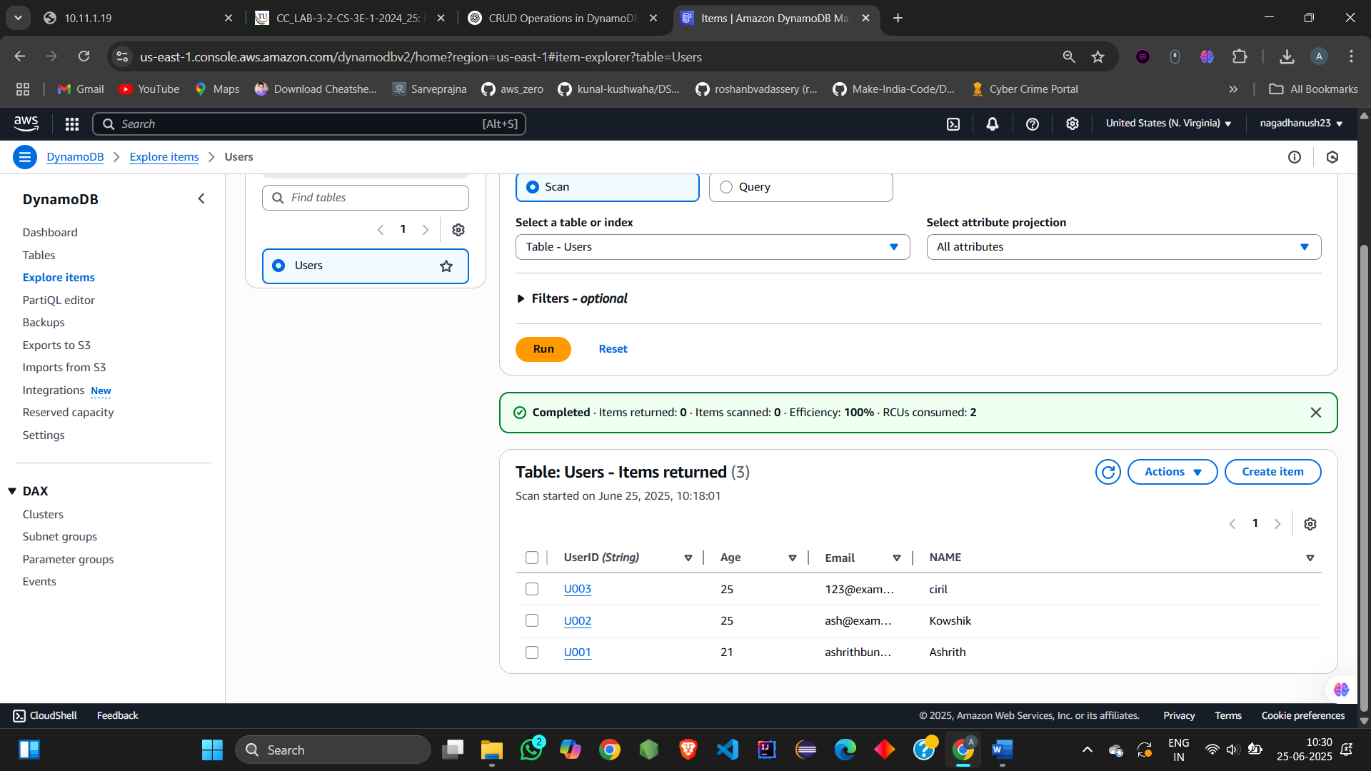

**Update (Form)**

1. Click on item with UserID: U003
2. Click **Edit**

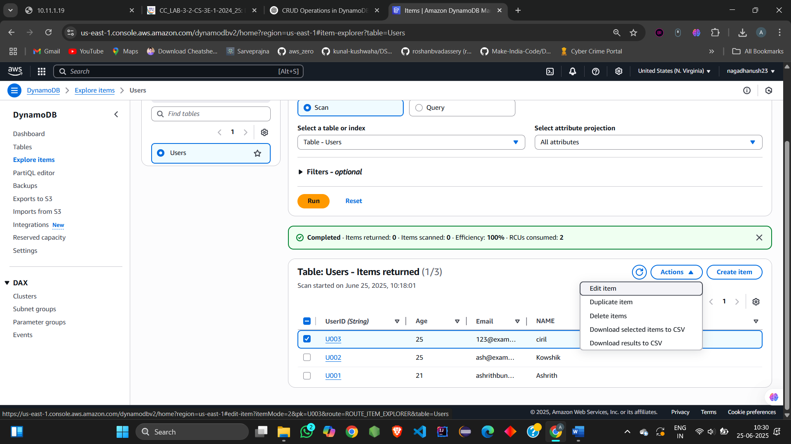

1. Update Email to: 123updated@example.com

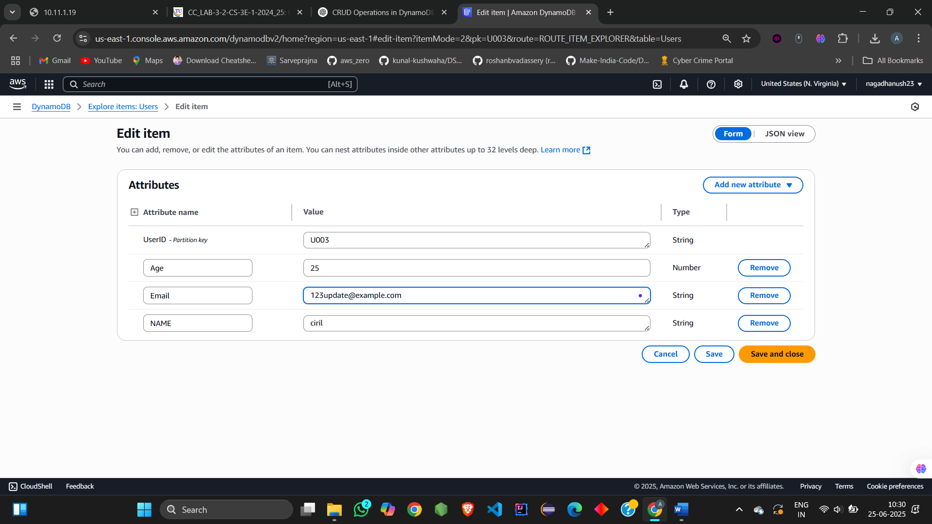

1. Click **Save changes**

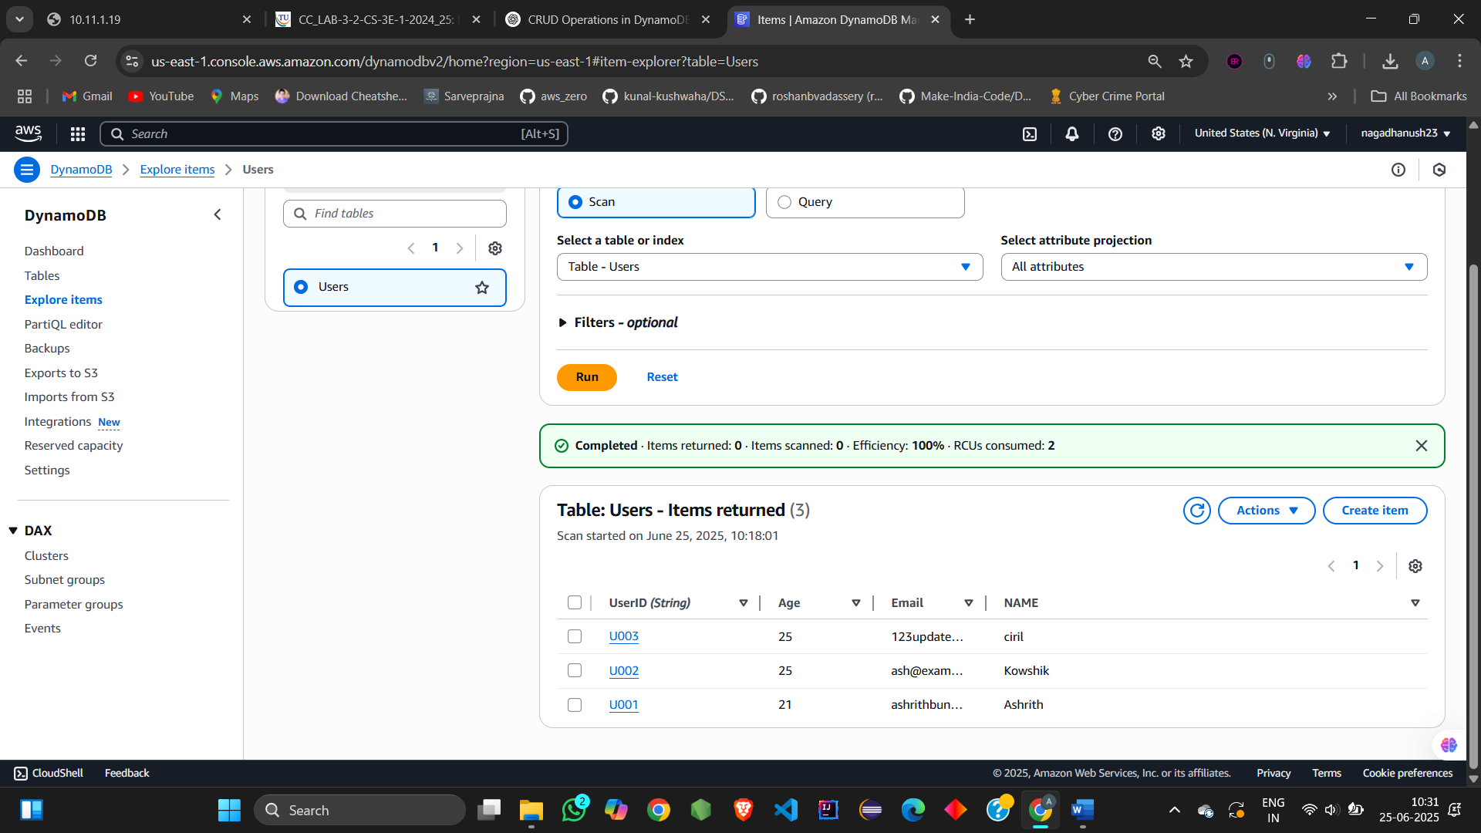

## **Delete (Form)**

1. Select item with UserID: U003
2. Click **Actions > Delete**

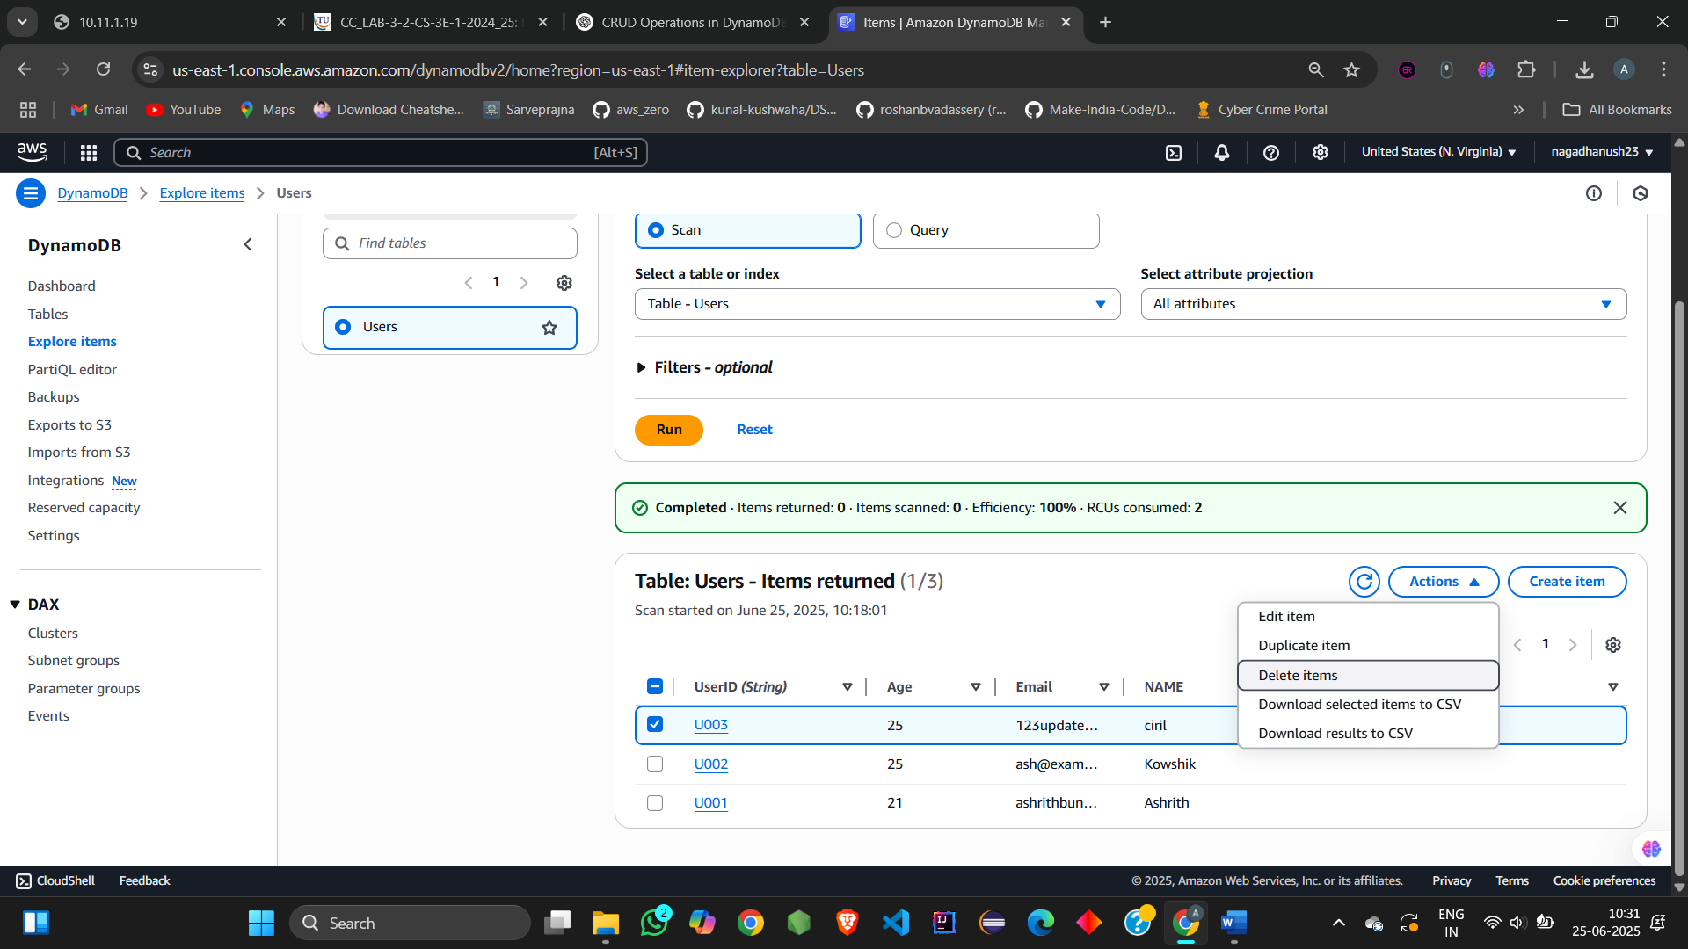

1. Confirm delete

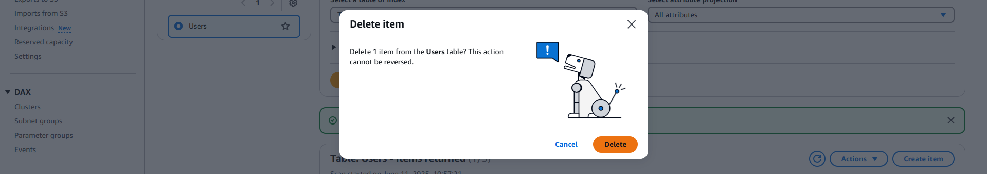

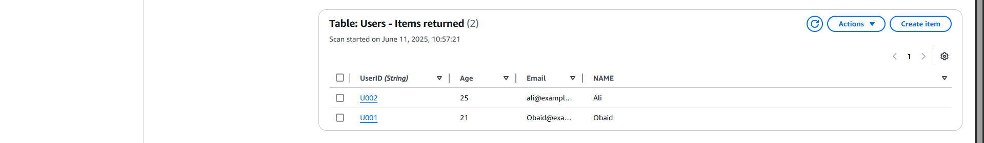Done with **Form method**

**STEP 3: CRUD Using JSON View**

## **✅ Create Items using JSON**

1. Click **Create item**
2. Switch to **JSON view**
3. Paste:

{

"UserID": {

"S": "U004"

},

"NAME": {

"S": "John"

},

"Age": {

"N": "28"

},

"Email": {

"S": "john@example.com"

}

}

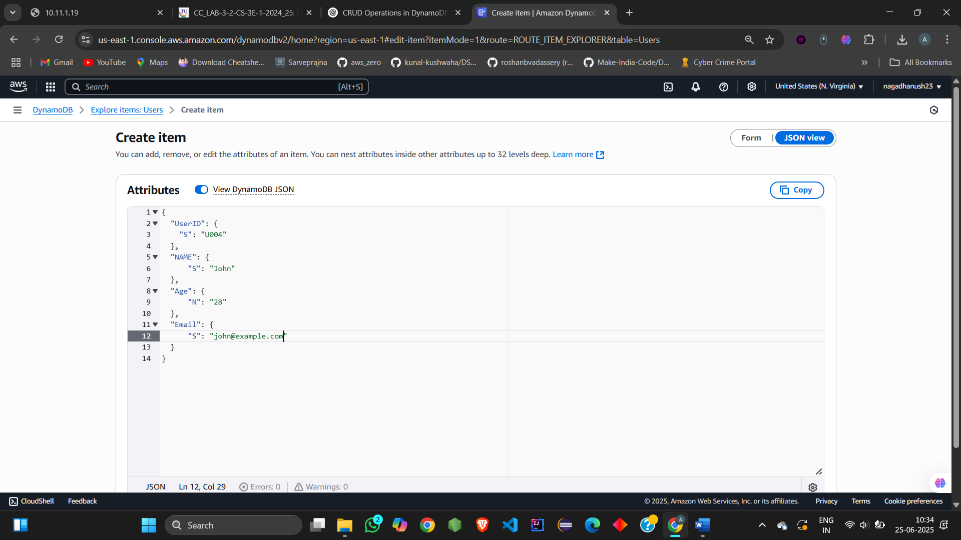

1. Click **Create item**

Repeat for:

{

"UserID": {

"S": "U005"

},

"NAME": {

"S": "Emma"

},

"Age": {

"N": "30"

},

"Email": {

"S": "emma@example.com"

}

}

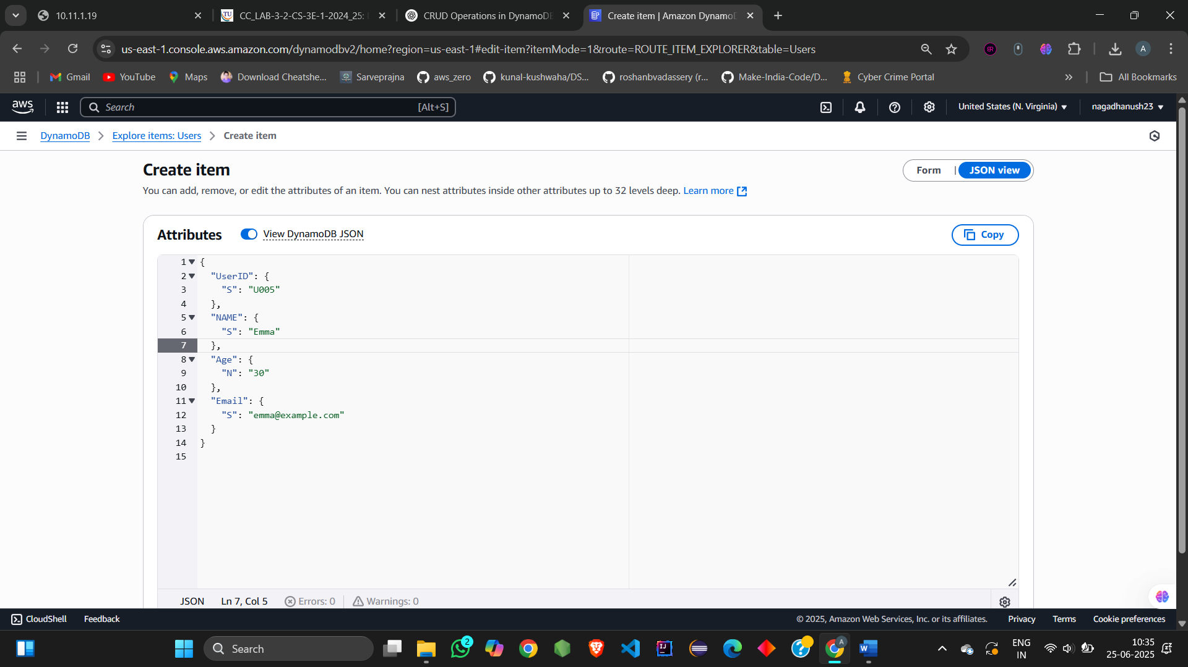

**Read (JSON)**

* Explore Table shows items including the ones added via JSON.

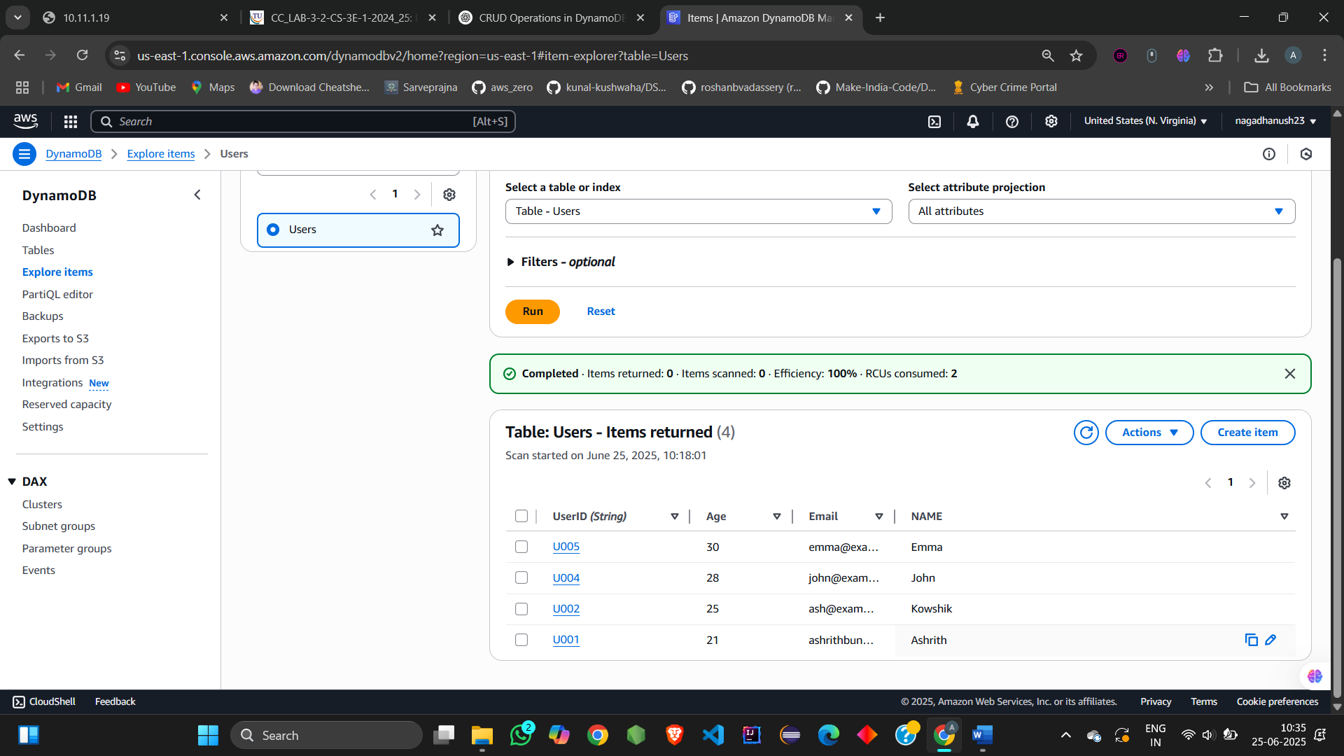

**Update (JSON)**

1. Select item with UserID: U005
2. Click **Edit**

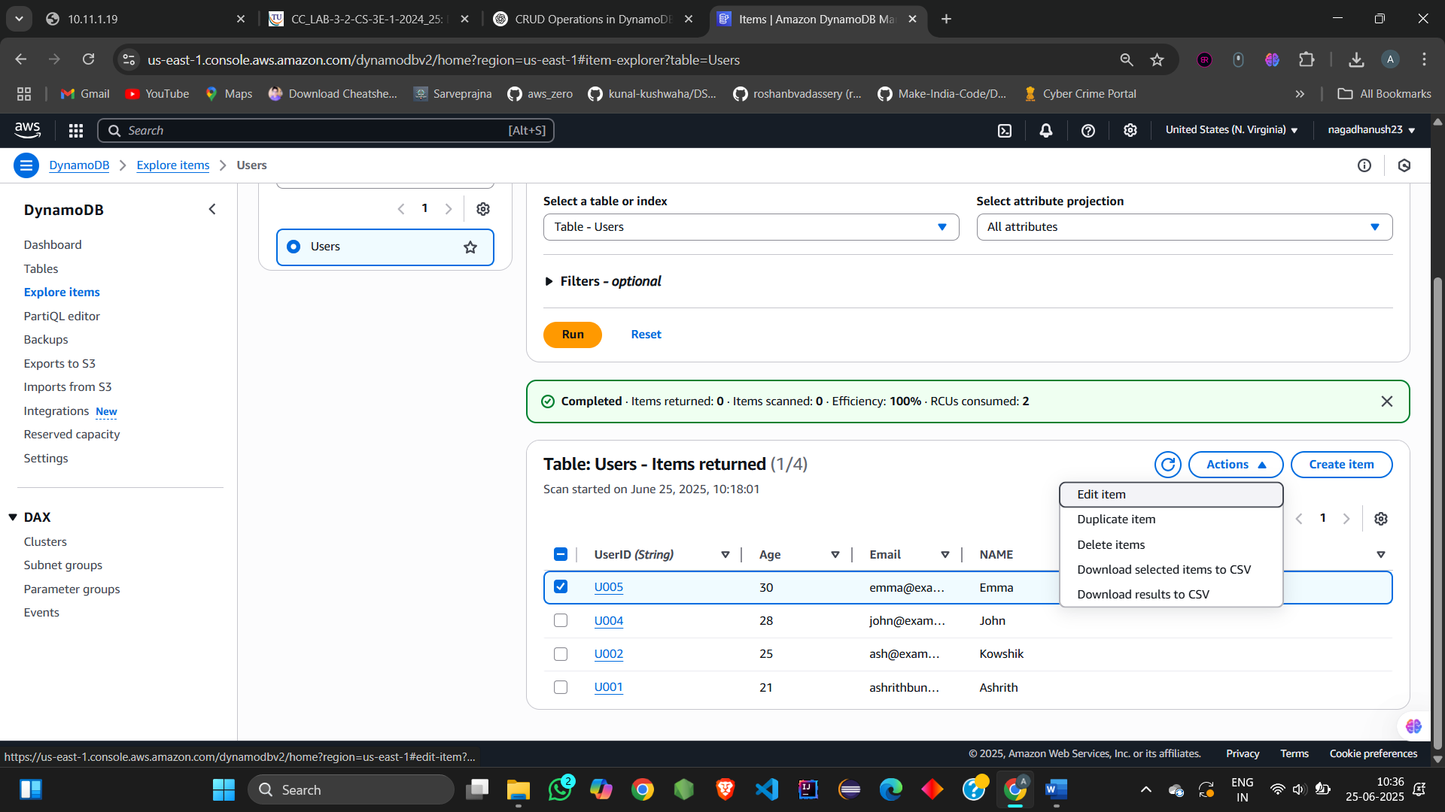

1. Change Email to emma.updated@example.com

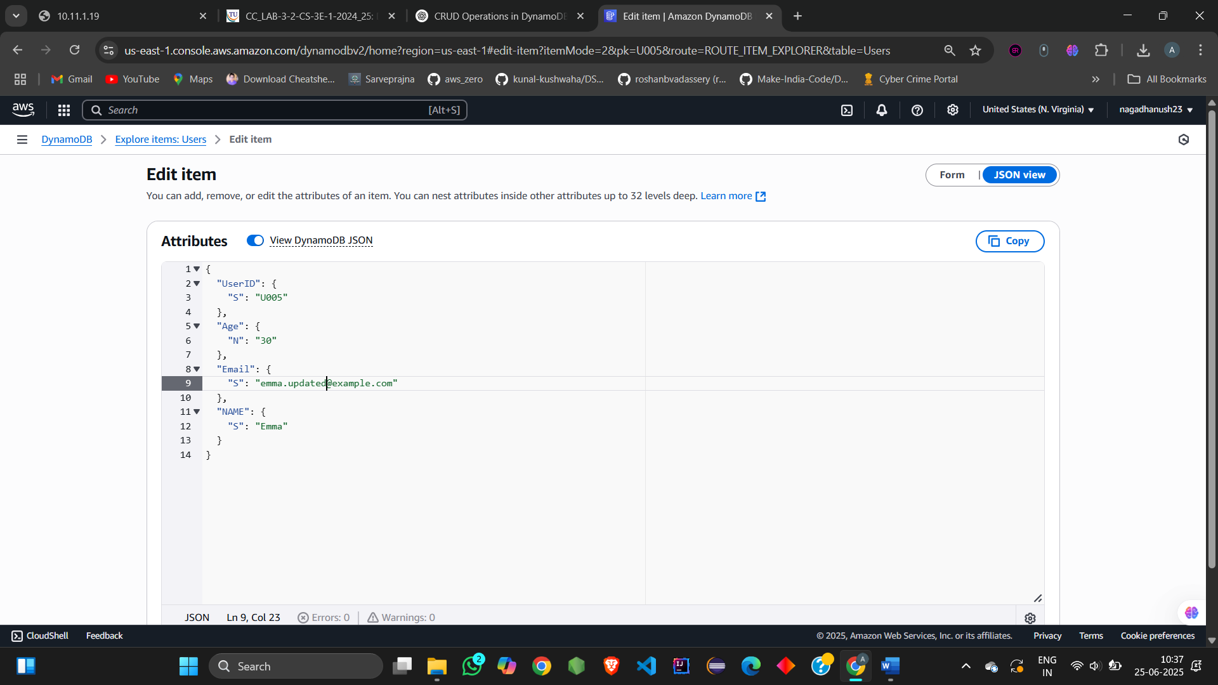

1. Click **Save changes**

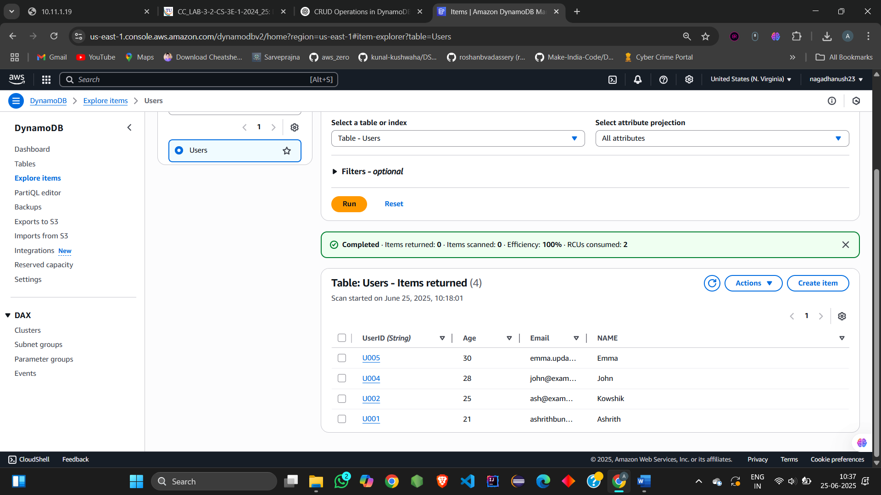

**Delete (JSON)**

1. Select U005 → Actions → Delete

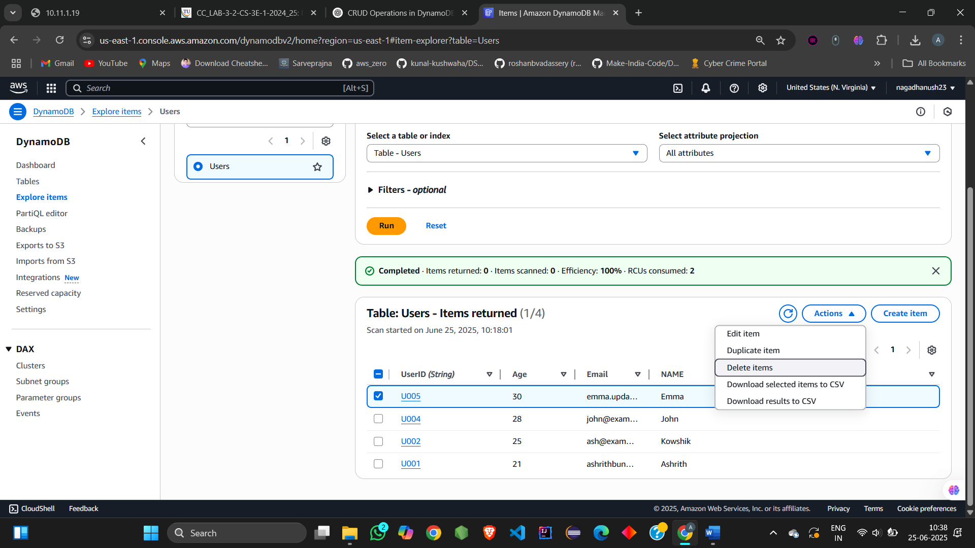

Done with **JSON method**

**STEP 4: CRUD Using PartiQL**

Go to: **DynamoDB → PartiQL Editor**

## **Create Items (PartiQL)**

INSERT INTO "Users" VALUE {

'UserID': 'U006',

'Name': 'Arjun',

'Age': 24,

'Email': 'arjun@example.com'

};

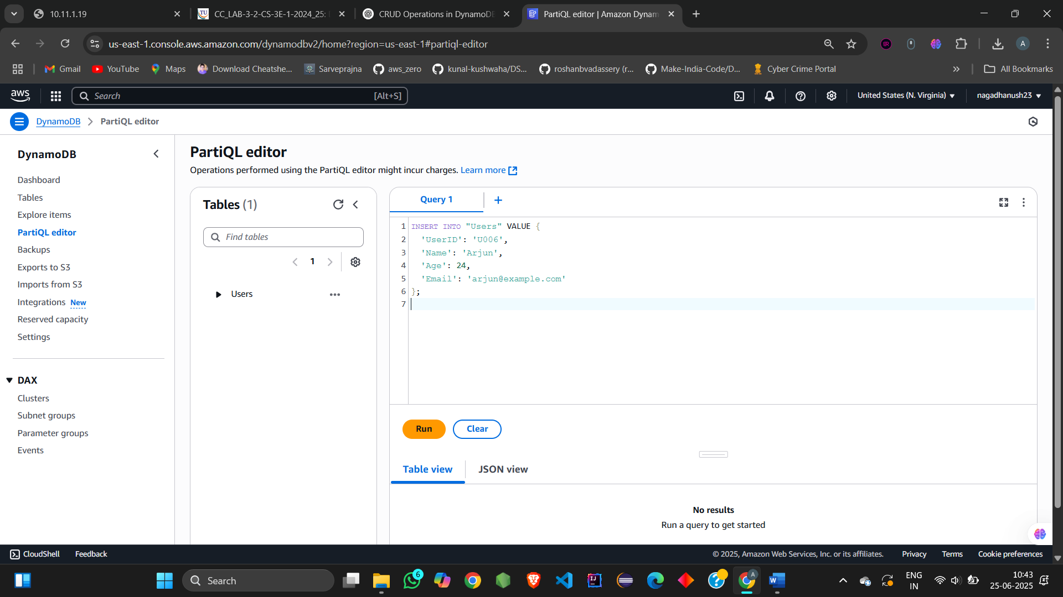

INSERT INTO "Users" VALUE {

'UserID': 'U007',

'Name': 'Nazriya',

'Age': 40,

'Email': 'nazriya@example.com'

};

**Read (PartiQL)**

SELECT * FROM "Users" WHERE "UserID" = 'U007';

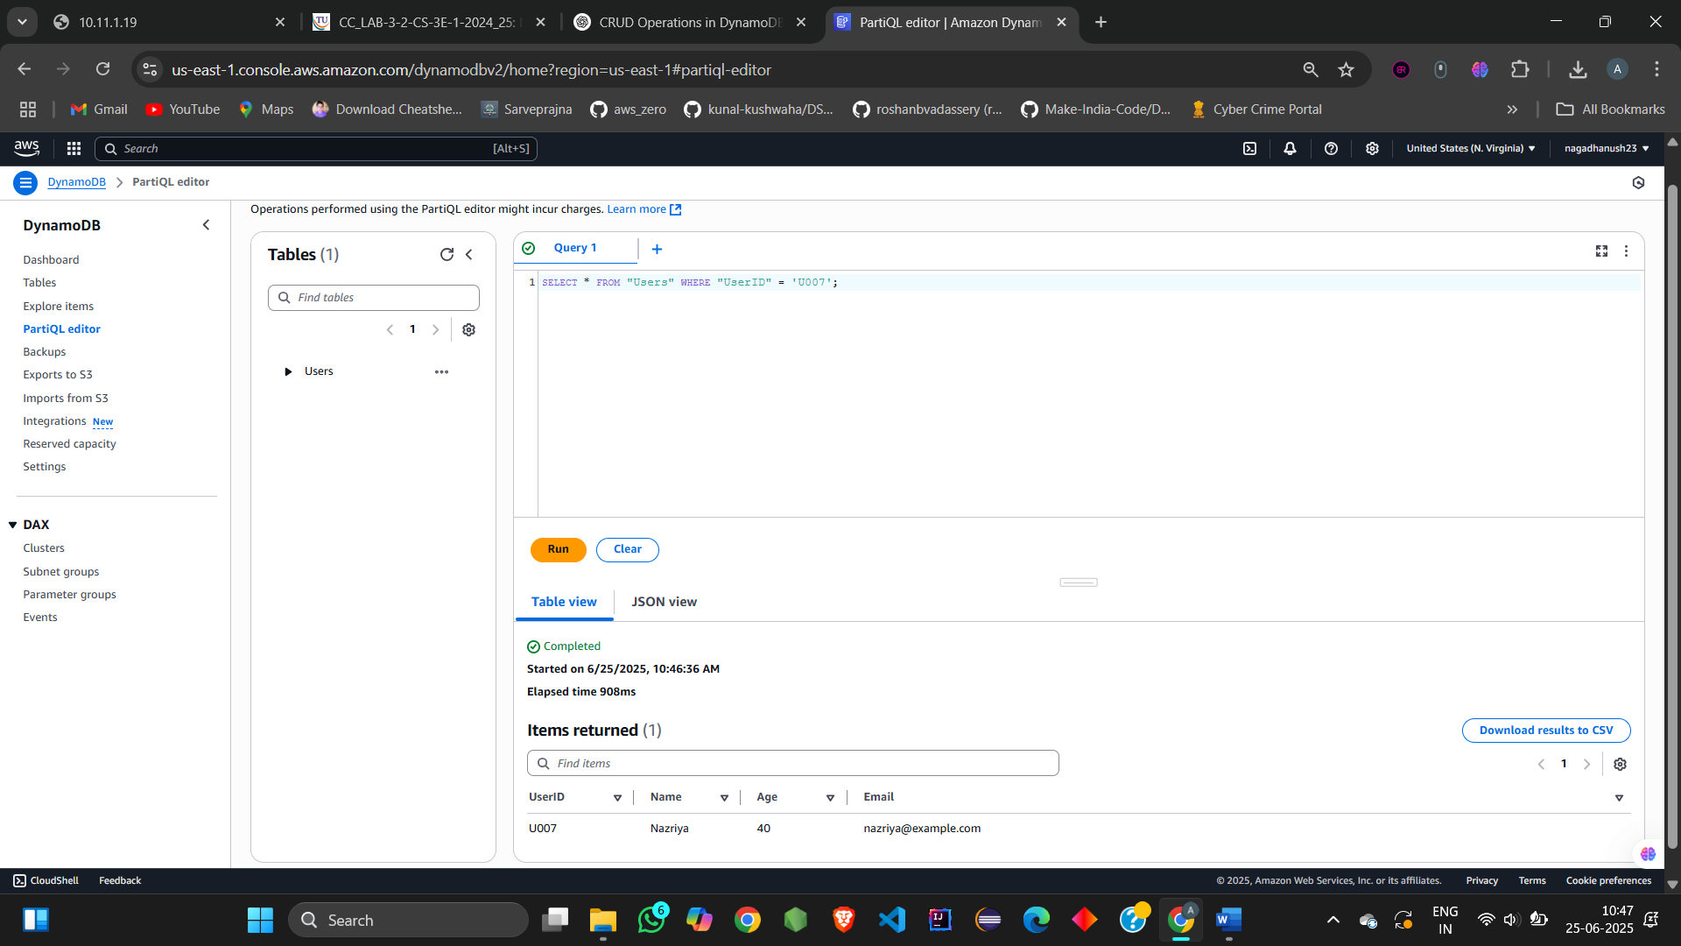

**Update (PartiQL)**

UPDATE "Users" SET "Age" = 41 WHERE "UserID" = 'U007';

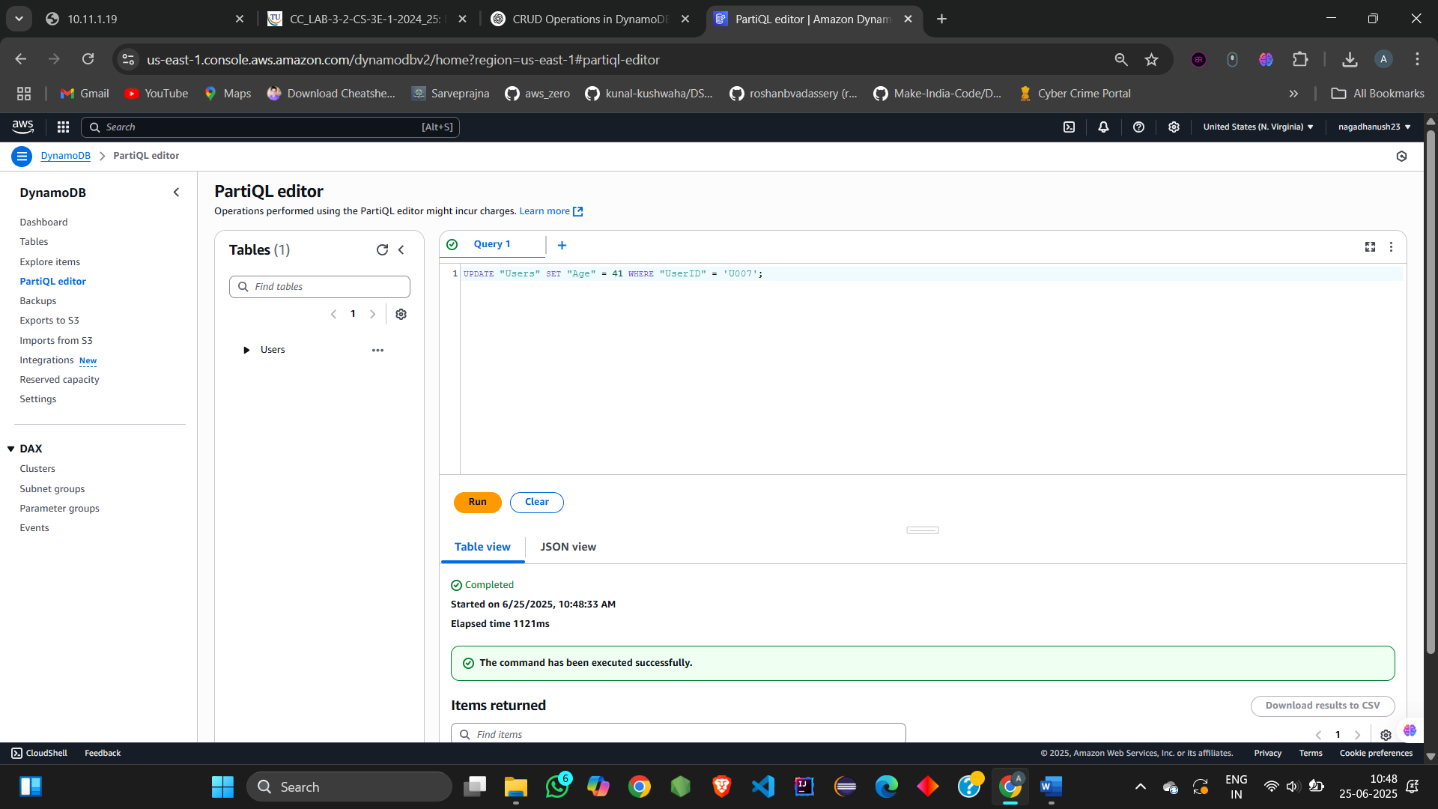

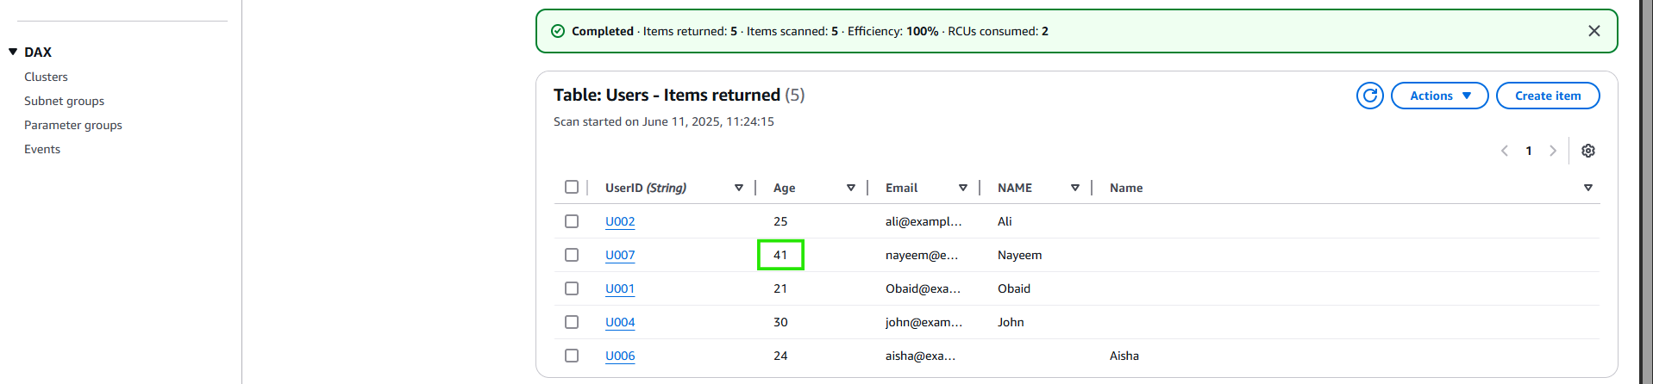

**Delete (PartiQL)**

DELETE FROM "Users" WHERE "UserID" = 'U006';

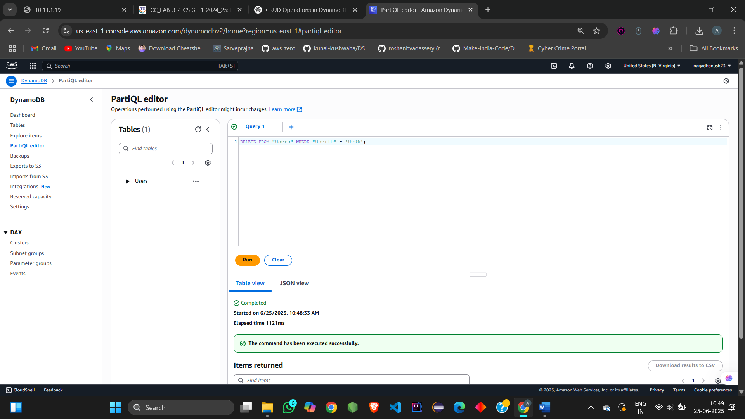

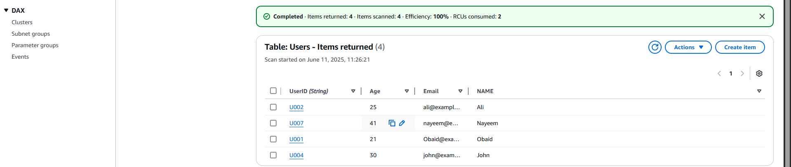

Done with **PartiQL method**

**STEP 5: Read Using Scan**

**What it does:**

Shows **all items** regardless of keys

### **✅ Steps**

1. Go to **Tables > Users**
2. Click **Explore Table Items**
3. The default view is a **Scan** — it loads **all records**

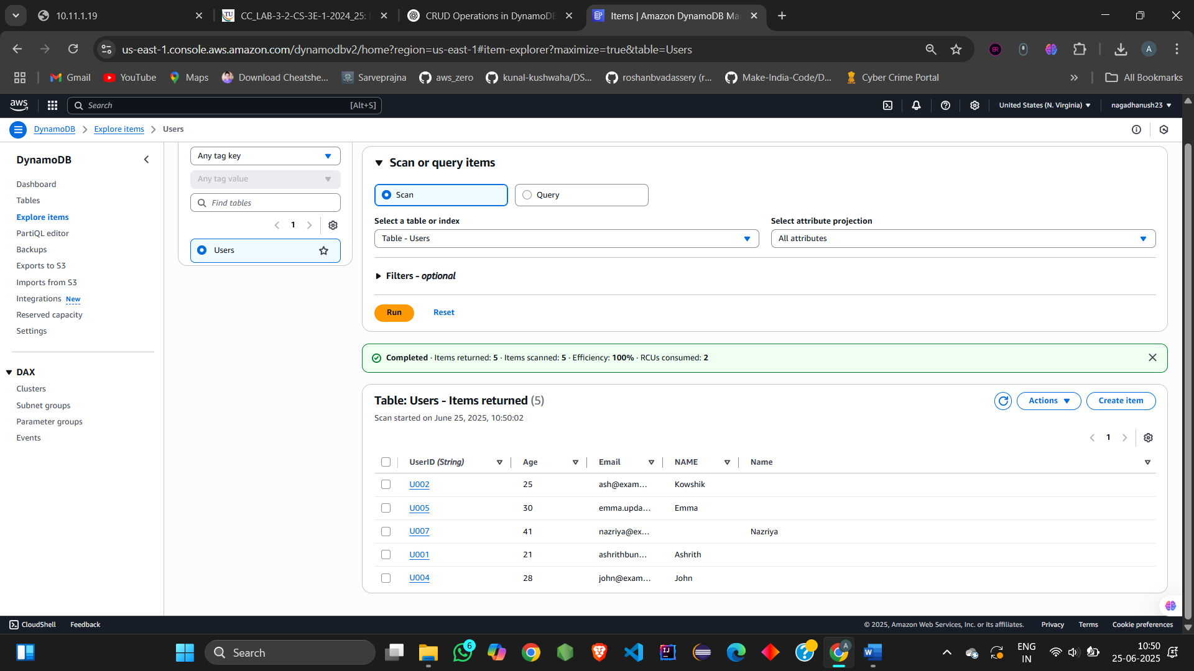

### **📝 Optional:**

* Click **Add filter**
  + Example: Age > 25

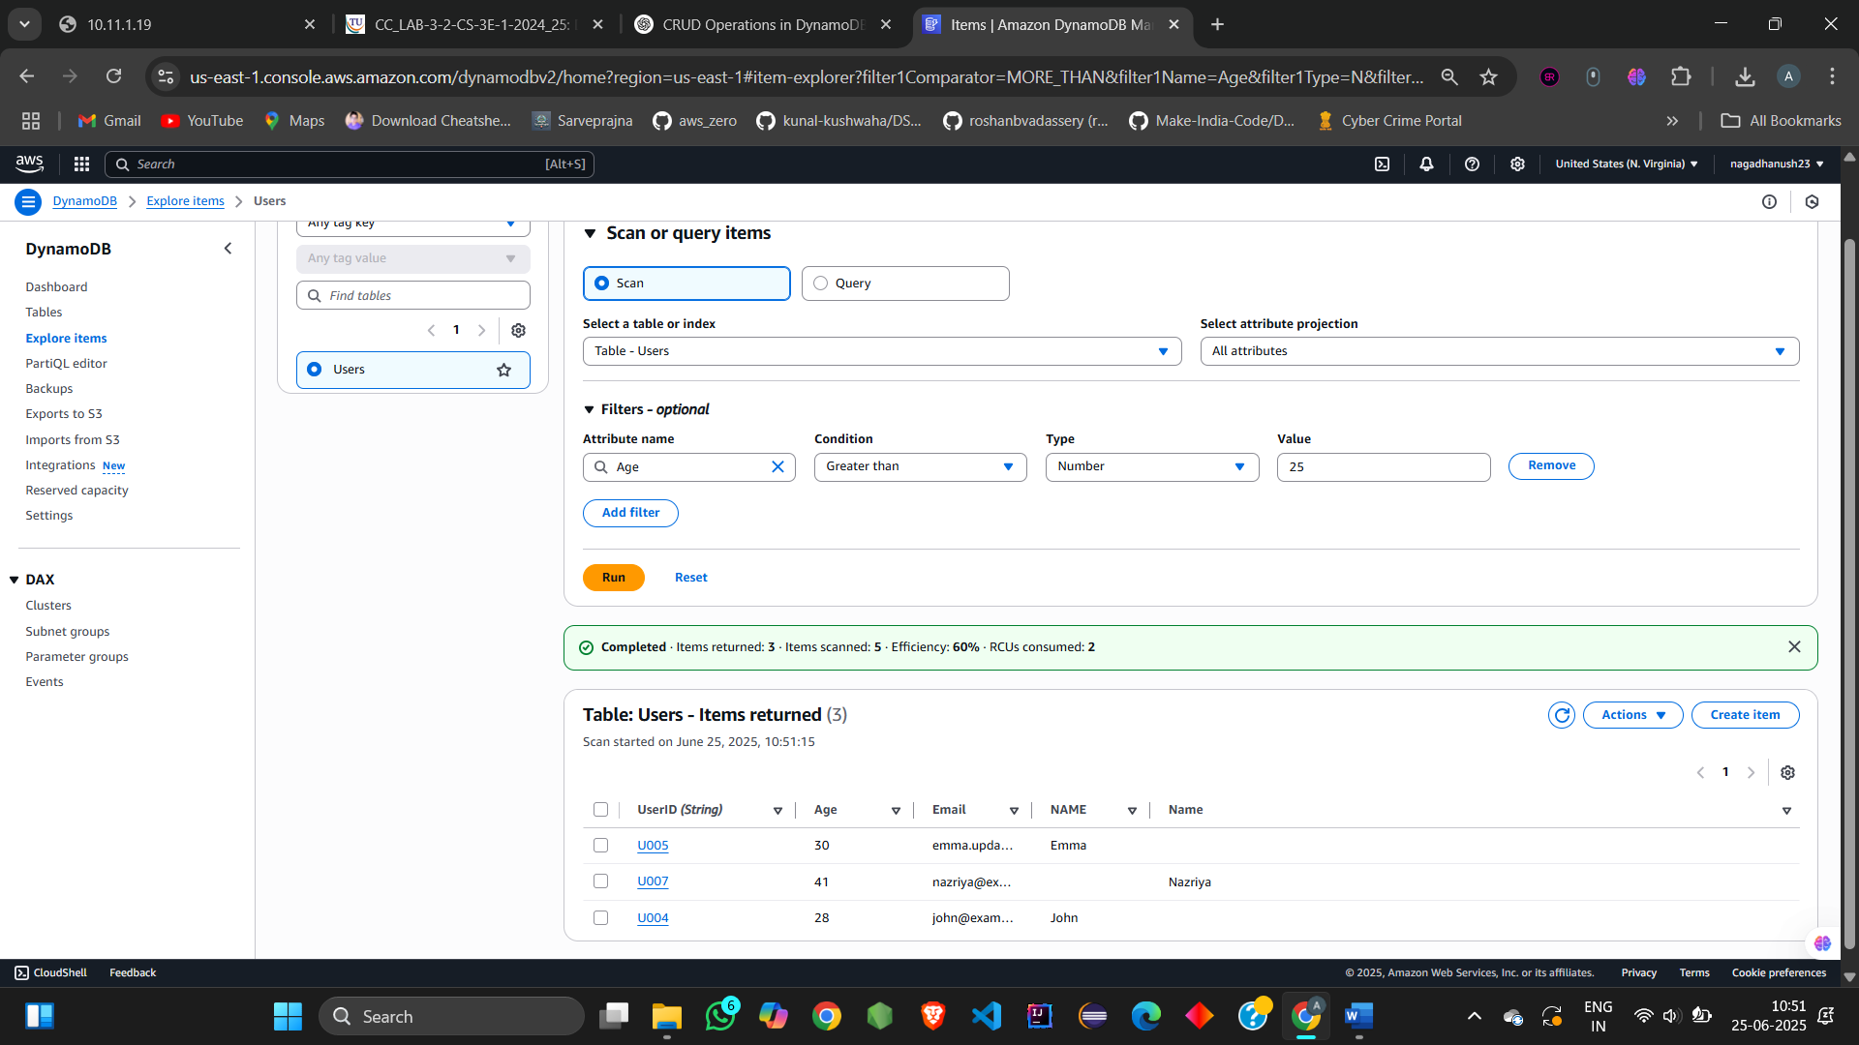

**Scan (read-only) done**

**STEP 6: Read Using Query (in Explore Items > Query tab)**

**What it does:**

Fetches item(s) **based on partition key**

**✅ Steps**

1. In **Explore Table Items**, switch to the **Query** tab
2. In UserID, enter a value, like U001
3. Click **Run**
4. The item with UserID: U001 will be shown

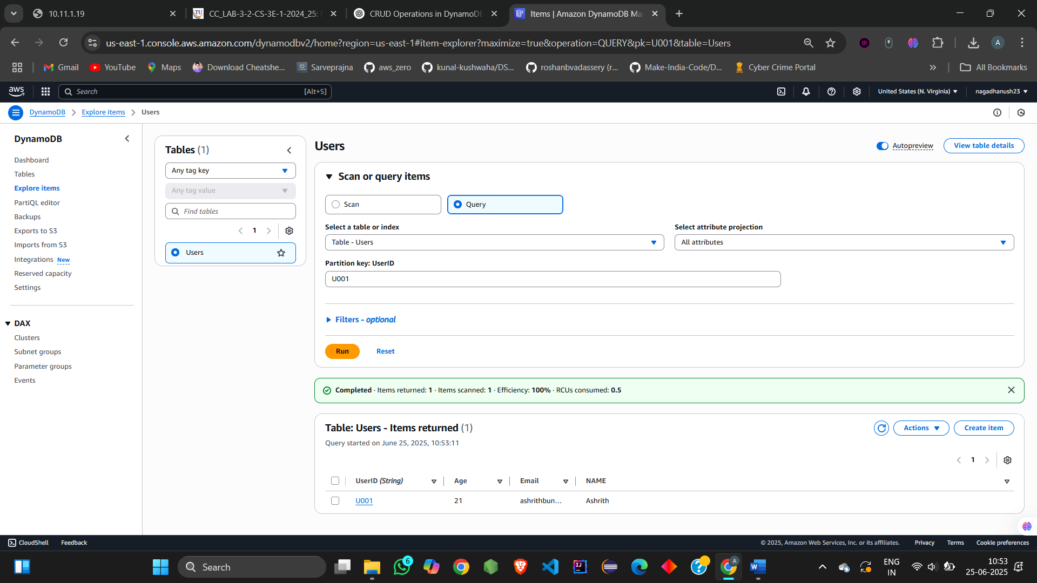

### **📝 Optional filter:**

* Click **Add filter**
  + Example: Filter by Age > 20

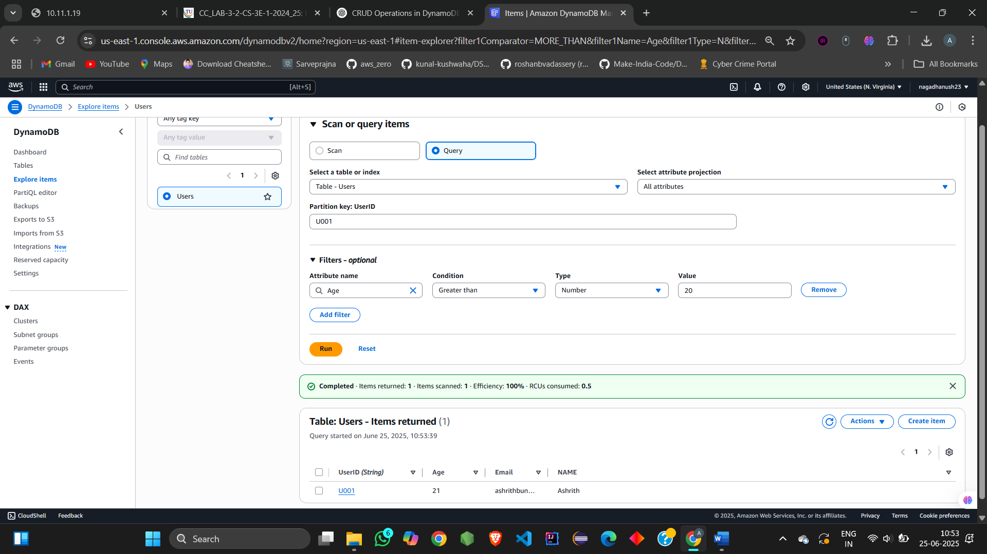

**Query (read-only) done**

## **IAM**

## **Step 1: Create an IAM Role with EC2 Permissions**

1. **Go to** the AWS Management Console:<https://console.aws.amazon.com/iam/>
2. **In the sidebar**, click **Roles** → **Create role**

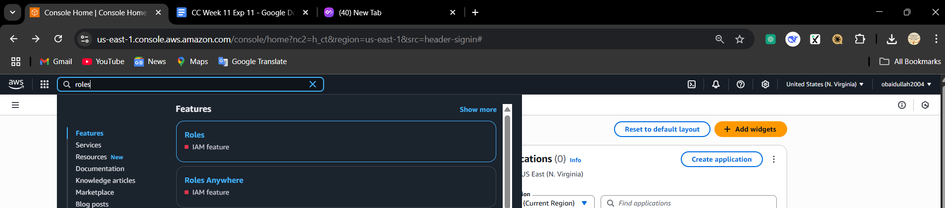

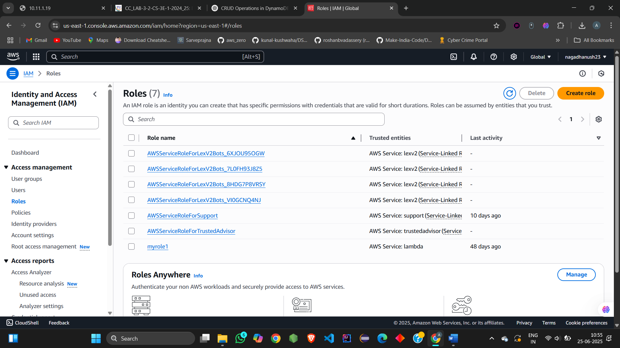

1. **Select trusted entity type**: Choose **AWS service**

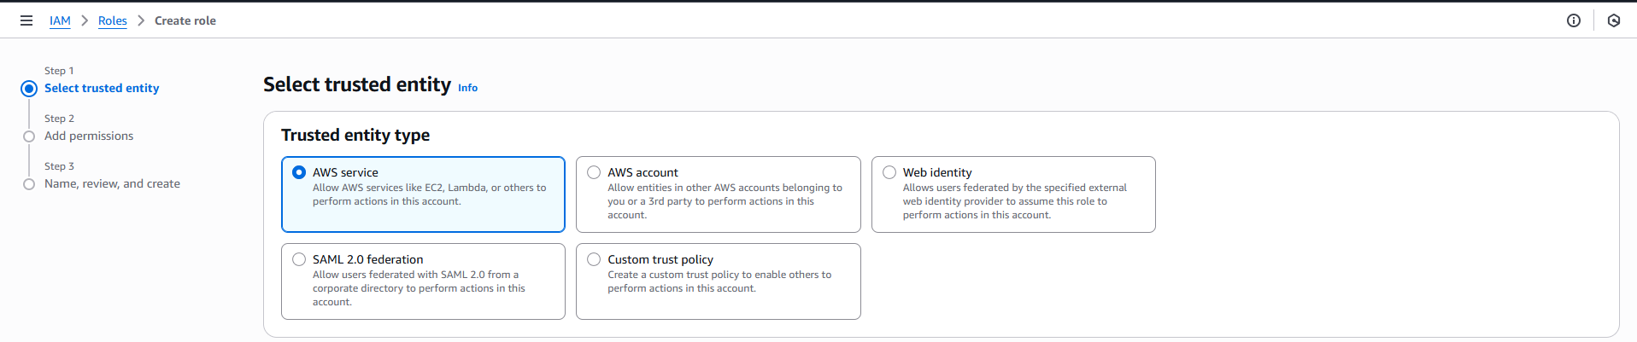

1. **Use case**: Select **EC2** → Click **Next**



1. **Attach Permissions**:  
    Search and select these **managed policies** (or create custom):
   * AmazonEC2ReadOnlyAccess *(for Describe actions)*

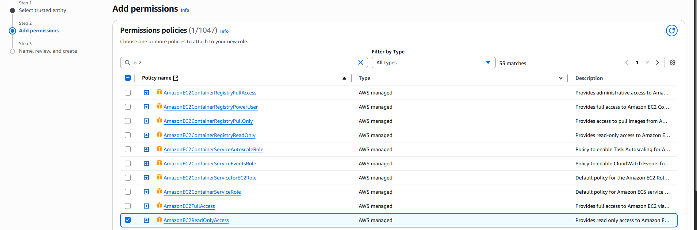

*I didn’t create the IAM role yet*

* + OR create a **custom policy** (next step) with only these permissions:
    - ec2:DescribeInstances
    - ec2:StartInstances
    - ec2:StopInstances
    - ec2:RebootInstances
    - ec2:DescribeVolumes

*(To add custom policy: Click "Create policy" > "JSON" tab and paste this:)*  
{

"Version": "2012-10-17",

"Statement": [

{

"Effect": "Allow",

"Action": [

"ec2:DescribeInstances",

"ec2:StartInstances",

"ec2:StopInstances",

"ec2:RebootInstances",

"ec2:DescribeVolumes"

],

"Resource": "*"

}

]

}

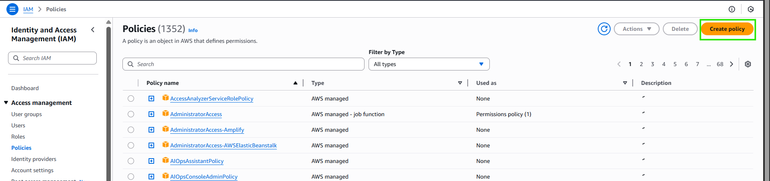

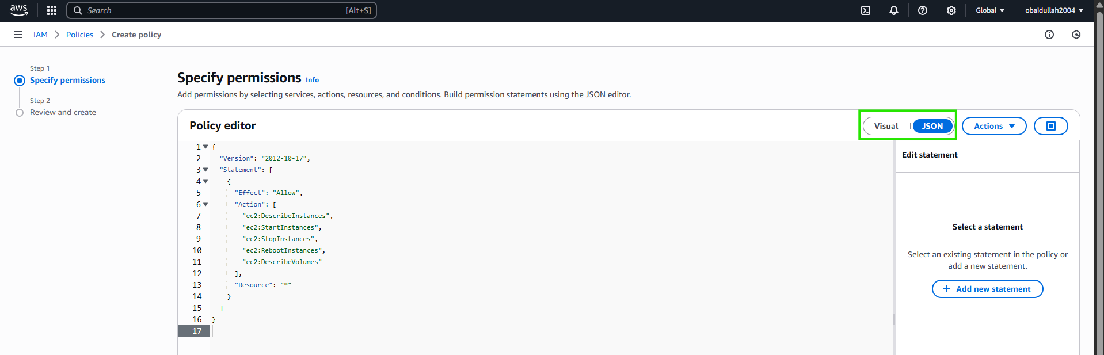

* + Save it as **EC2CustomPolicy**

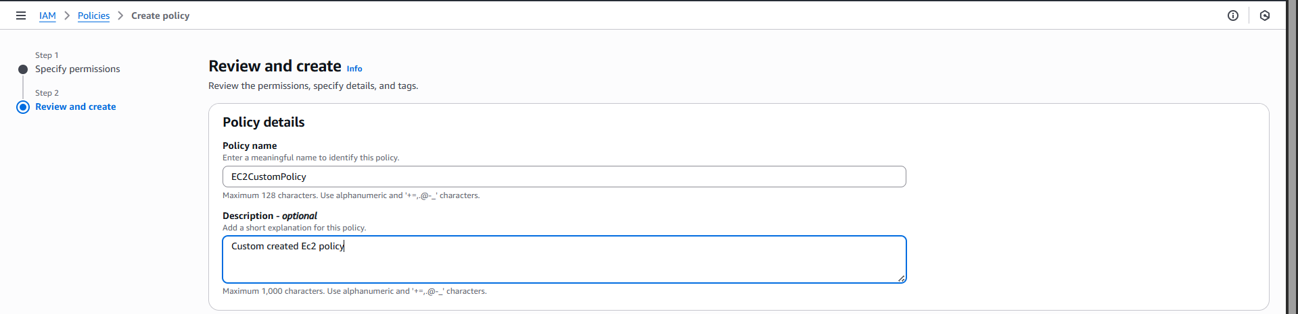

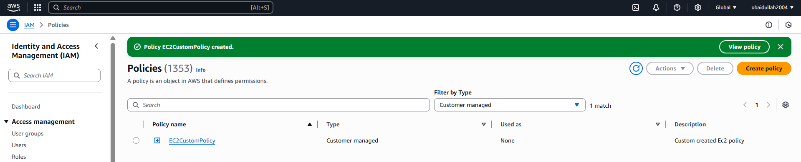

* + Go back to role creation and attach this policy.

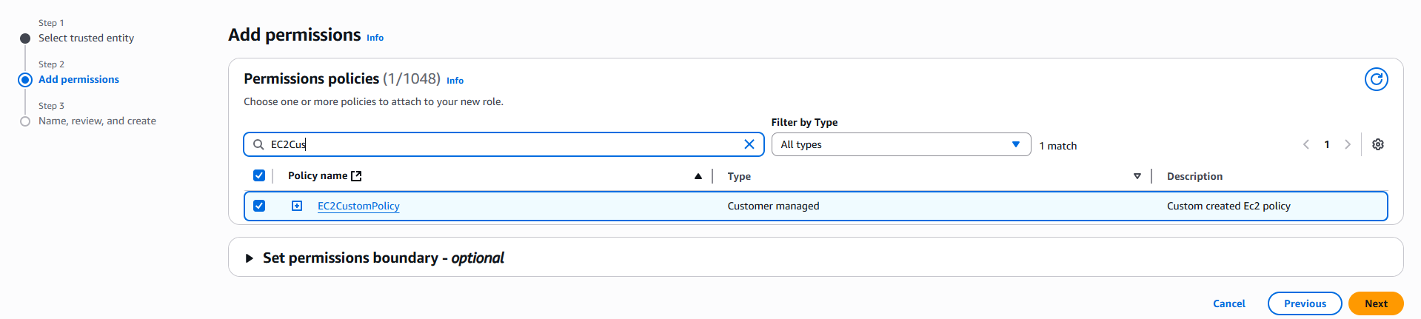

1. Click **Next**, name it EC2CustomRole, and click **Create Role**

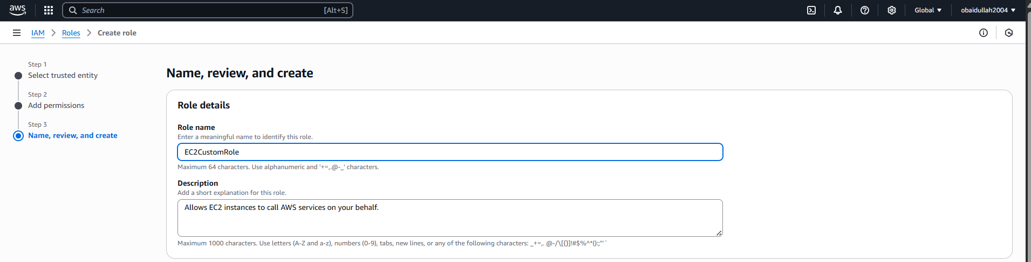

### **Step 2: Attach IAM Role to an EC2 Instance**

You can either:

* Attach it during EC2 launch (next step), or
* Attach it to an existing instance:

To attach to an existing EC2 instance:

1. Go to **EC2 > Instances (**58a-existing-instance**)**

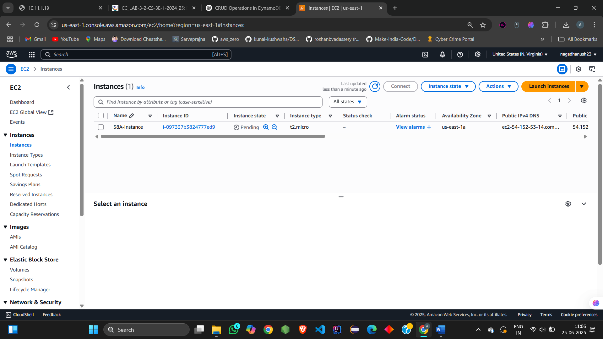

1. Select the instance → **Actions** > **Security** > **Modify IAM Role**

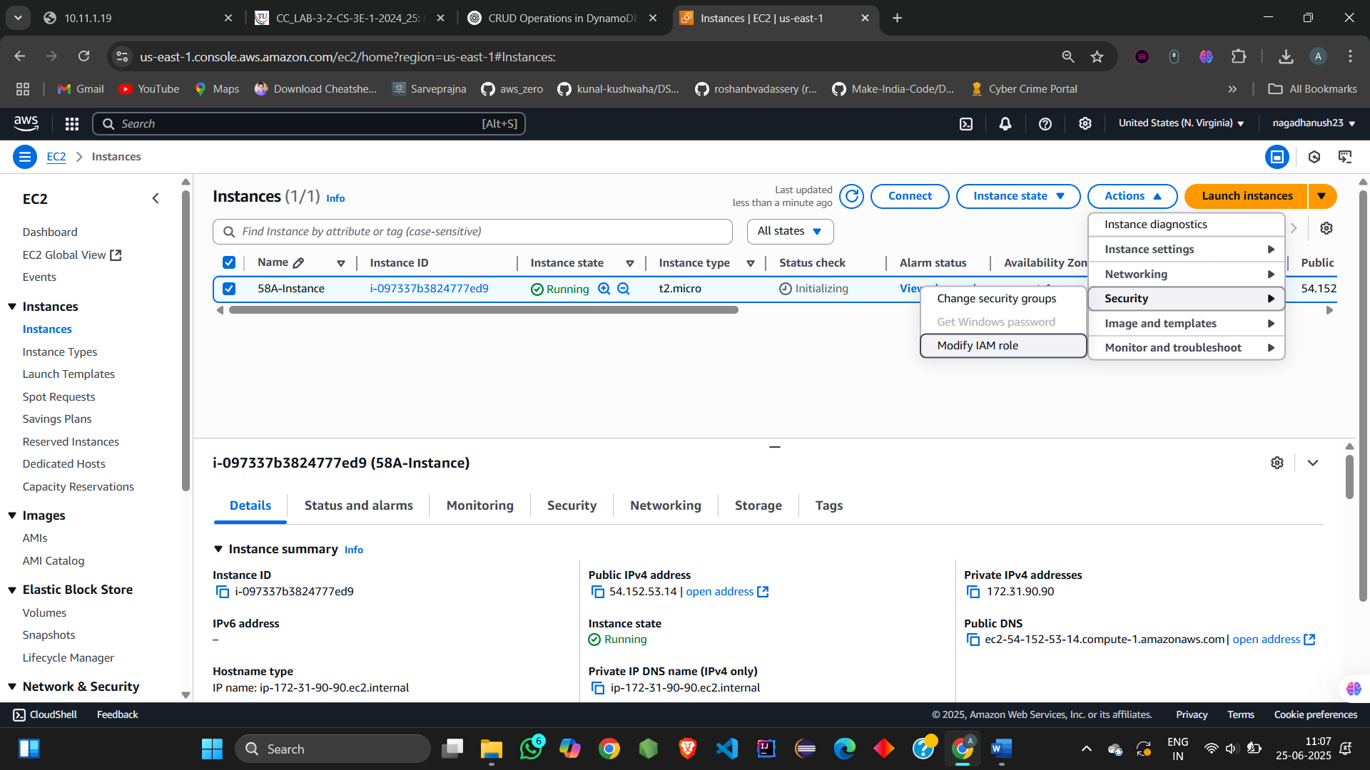

1. Choose EC2CustomRole → **Update IAM Role**

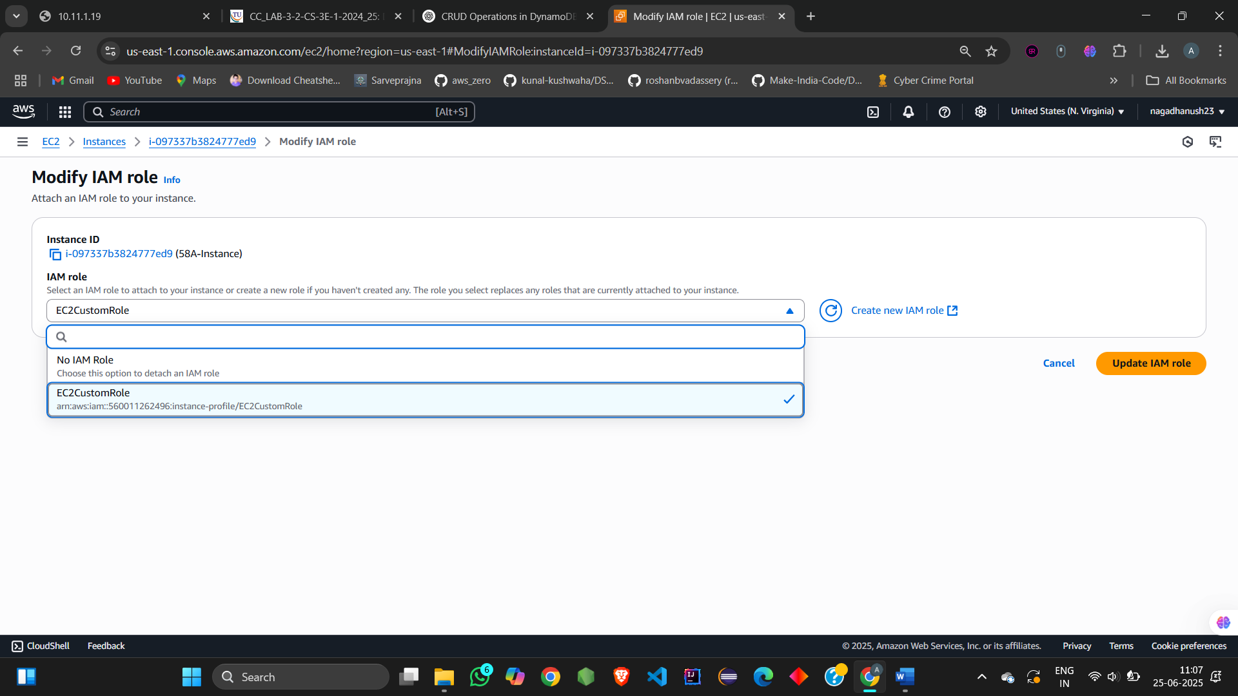

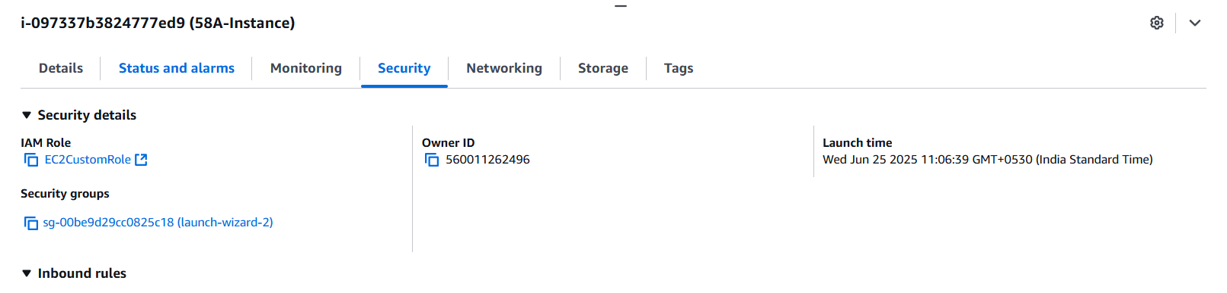

### **Step 3: Launch EC2 Instance with Your IP Access**

1. Go to **EC2 Dashboard** → **Launch Instance**
2. **Name** your instance (58a-new-instance)



1. **Choose AMI** (e.g., Amazon Linux 2023)
2. **Instance Type**: t2.micro (Free tier)
3. **Key Pair**: Choose existing or create a new one (you’ll need this to SSH)
4. **Network Settings**:
   * Click **Edit**
   * Allow **SSH** from **My IP** (automatically fills your IP)

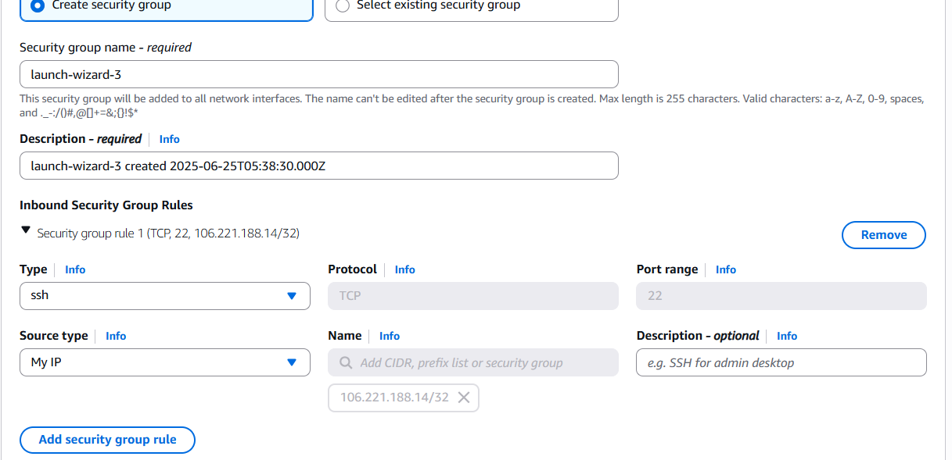

* + Optional: Create new Security Group or use existing

1. **Advanced Details**:
   * Expand this section
   * Under **IAM instance profile**, choose EC2CustomRole

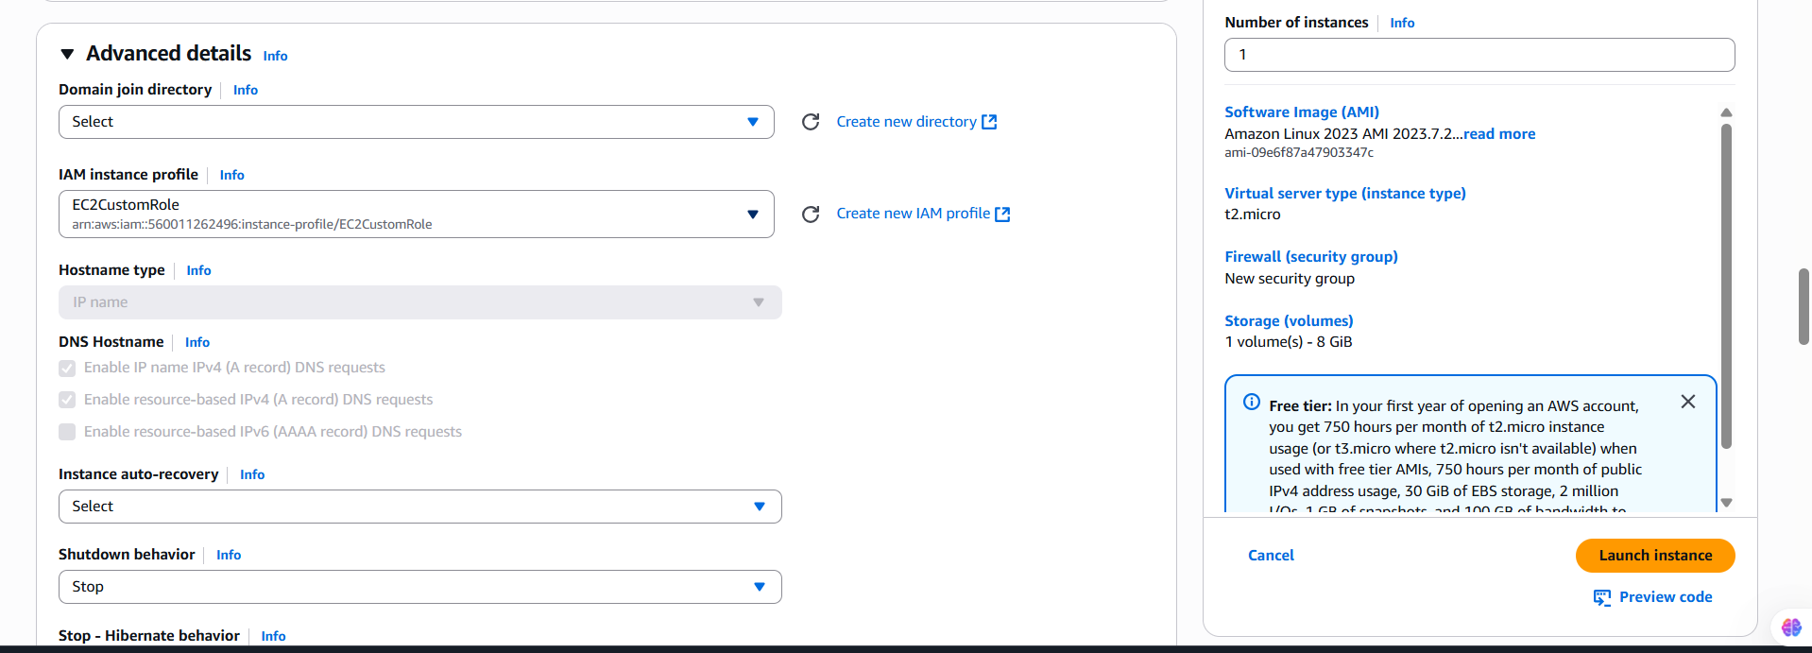

1. Click **Launch Instance**

### **Step 4: Connect to EC2 Using SSH**

1. Go to **Instances**, find your instance
2. Copy the **Public IPv4 address**
3. Open your terminal:  
   ssh -i "58a-new.pem" ec2-user@ec2-34-230-35-206.compute-1.amazonaws.com

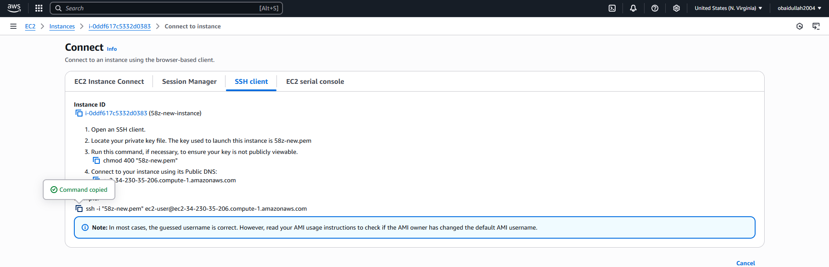

### **Step 5: Verify IAM Role and Permissions**

1. Once logged in via SSH:  
   Check IAM role attached:  
   curl -X PUT "http://169.254.169.254/latest/api/token" \ -H "X-aws-ec2-metadata-token-ttl-seconds: 21600"

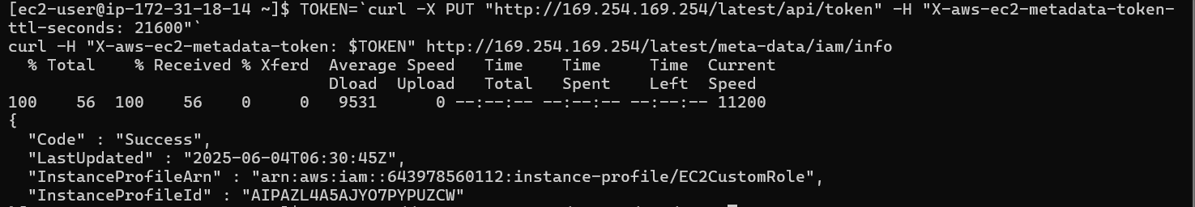

1. Use AWS CLI to test (already installed on Amazon Linux):  
   Run:  
     
   aws ec2 describe-instances

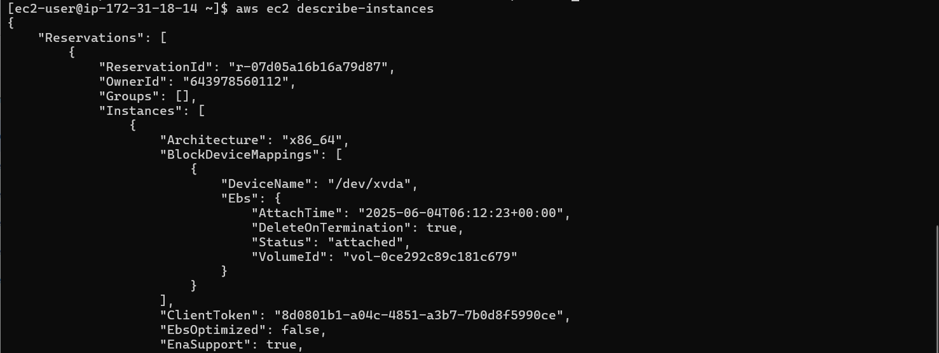

* + Try:  
      
    aws ec2 reboot-instances --instance-ids <your-instance-id>

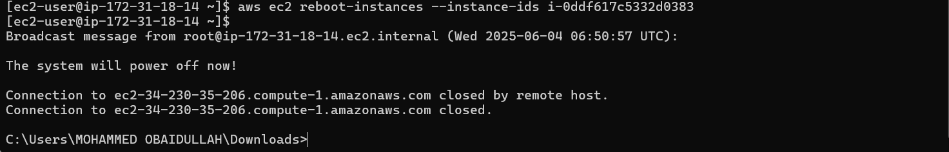

* + If successful → permissions are working correctly.